CEE 5614: Analysis of Air Transportation Systems Spring 2022

Final Project: Delay Analysis and Flight Trajectory Operations

Date Due: May 11, 2022 by Midnight Instructor: Trani

## Problem 1

An airport has a runway configuration and saturation capacity diagram as shown in Figures 1 and 2, respectively. The airport operates in segregated mode for safety (one runway for arriv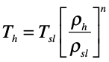als and one for departures). The problem is a follow-up of the problem you solved in Exam 2.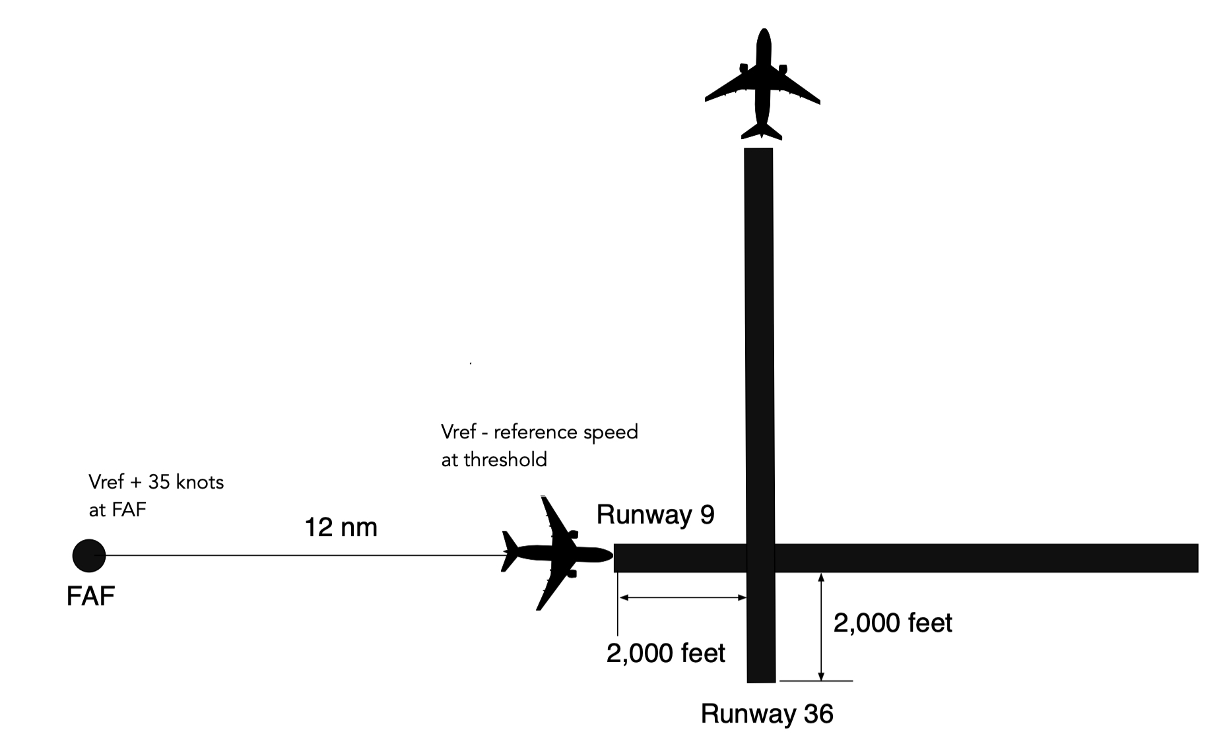

Figure 1. Runway Configuration and Arrival-Departure Diagram for Problem 1.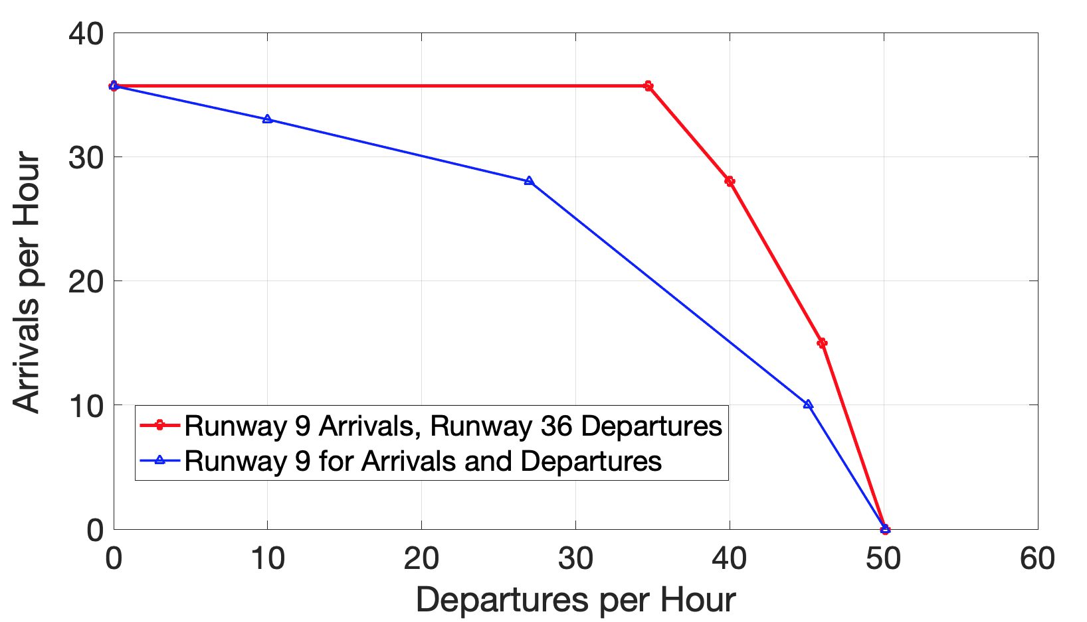

Figure 2. Runway Capacity Diagrams for One and Two Runway Operations for Runway Configuration of Figure 1. The Red Line Assumes the Arrival-Departure Separation is 2 nm (see Exam 2 solution if needed).

The numerical values of arrivals and departures are presented in Table 1.

Table 1. Arrival and Departures per Hour for Two Runway Operating Configurations ( see Figure 1).

|  |  |  |  |  |
| --- | --- | --- | --- | --- |
| Two Runways | |  | One Runway |  |
| Departures | Arrivals |  | Departures | Arrivals |
| 0 | 35.7 |  | 0 | 35.7 |
| 34.7 | 35.7 |  | 10 | 30 |
| 40 | 28 |  | 27 | 28 |
| 46 | 15 |  | 45.1 | 10 |
| 50.1 | 0 |  | 50.1 | 0 |

1. Table 2 shows the daily demand function for arrival and departures at the airport. Use the **deterministic queueing model** to estimate the **average delays per flight delayed** to both arrivals and departures at the airport. Consider that air traffic controllers organize the traffic from an initial far-away fix (called Fix 1 in the Exam 2) to the FAF (final approach fix) to control the arrival separation and hence regulate the operational point along boundary the Pareto diagram (arrival-departure diagram). For example, Figure 2 shows that the two runway configuration, can support 40 departures on runway 36 and 27 arrivals on runway 9 simultaneously. In a given day, no more than three distinct points on the Pareto boundary can be achieved because it takes time to reconfigure the separations between arrivals. In your calculations, tell me the operating point selected on the Pareto frontier of the arrival-departure diagram.
2. Estimate the annual cost of delay to airlines if the hourly cost of for an arrival is $6,500/hr and the hourly cost of departures is $3,800/hr. Assume the airport has daily operations similar to Table 1 for 365 days a year.
3. Estimate the annual cost of delay to passengers if the value of time for a passenger is $36/hr. The average passengers per flight at the airport is 135 passengers (typical in the United States).
4. A third runway has been planned for the year 2027 to the South of runway 9. The airport authority expect demand to growth at 4% per year for the next ten years. Would you recommend the third runway based on the analysis done and extrapolating the future delays?
5. If a third runway is built state what is the recommended separation between the existing runway 9 and the new parallel runway. Assume PRM and ADS-B (one second) position data technology is available to the project.
6. How would you recommend the third runway be operated at the airport? Be specific about your recommendation. For example, will the third runway serve arrivals and departures or just arrivals. Explain your rationale with numerical values and calculations.

Table 2. Flight Demand for Problem 1. Demand Values are Per Hour.

| **Time Period (Bin Center)** | **Arrivals/hr** | **Departures /hr** | **Total Operations/hr** |
| --- | --- | --- | --- |
| 0.5 | 0 | 2 | 2 |
| 1.5 | 3 | 4 | 7 |
| 2.5 | 10 | 5 | 15 |
| 3.5 | 15 | 4 | 19 |
| 4.5 | 18 | 12 | 30 |
| 5.5 | 22 | 25 | 47 |
| 6.5 | 35 | 32 | 67 |
| 7.5 | 38 | 33 | 71 |
| 8.5 | 36 | 35 | 71 |
| 9.5 | 31 | 38 | 69 |
| 10.5 | 30 | 36 | 66 |
| 11.5 | 19 | 28 | 47 |
| 12.5 | 21 | 14 | 35 |
| 13.5 | 24 | 22 | 46 |
| 14.5 | 27 | 19 | 46 |
| 15.5 | 31 | 24 | 55 |
| 16.5 | 20 | 32 | 52 |
| 17.5 | 18 | 36 | 54 |
| 18.5 | 32 | 40 | 72 |
| 19.5 | 39 | 38 | 77 |
| 20.5 | 35 | 41 | 76 |
| 21.5 | 30 | 34 | 64 |
| 22.5 | 15 | 18 | 33 |
| 23.5 | 2 | 6 | 8 |
| Totals | 551 | 578 | 1129 |