CEE 4674: Airport Planning and Design Fall 2022

**Quiz 2 - Take Home**

**Open Notes and Internet**

**Instructor: A.A. Trani**

**Due: November 30, 2022 at midnight**

**Instructions**

Create a solution file using the word processor of your choice. Convert to PDF and submit to Canvas. Include all screen captures of all your work including aircraft manufacturer’s tables and figures, FAA nomographs and others.

# Honor Code Pledge

The information provided in this exam is my own work. I have not received information from another person while doing this exam.

_____________________________________________________________ (your signature/name)

Problem 1 (30 Points)

This problem analyzes the obstructions to navigation for the airport configuration shown in Figure 1. The airport is located at an elevation of 1,560 feet above mean sea level conditions. Runway 6/24 is a precision runway. Runway 14/32 is a non-precision runway with visibility minima down to 3/4 mile. The critical aircraft operating at the airport is the Boeing 787-8 Dreamliner (see Figure 2).

1. Analyze the three objects shown in Figure 1 and determine if any of the objects is an an obstruction to navigation. In your analysis, include checks for the following criteria:
   1. FAR Part 77,
   2. Runway OFZ,
   3. New runway siting criteria (FAA AC 150/5300-13B).
2. If any of the objects is an obstruction to navigation, what remedial actions can the airport authority take the mitigate the problem? Explain.

Clearly state the surface or criteria violated (if any). Show me your calculations in detail to receive credit.

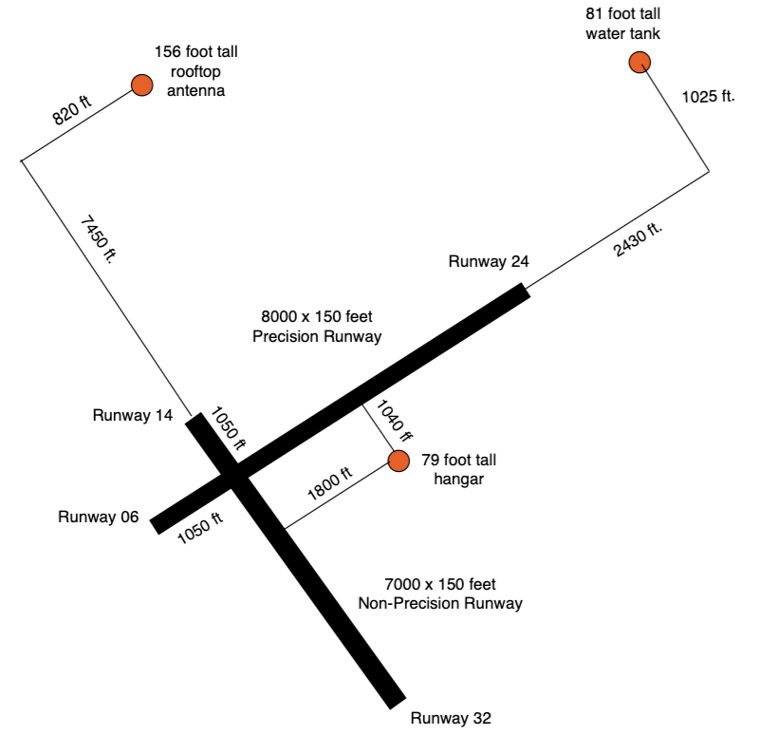

Figure 1. Potential Obstructions to Navigation for Problem 1.

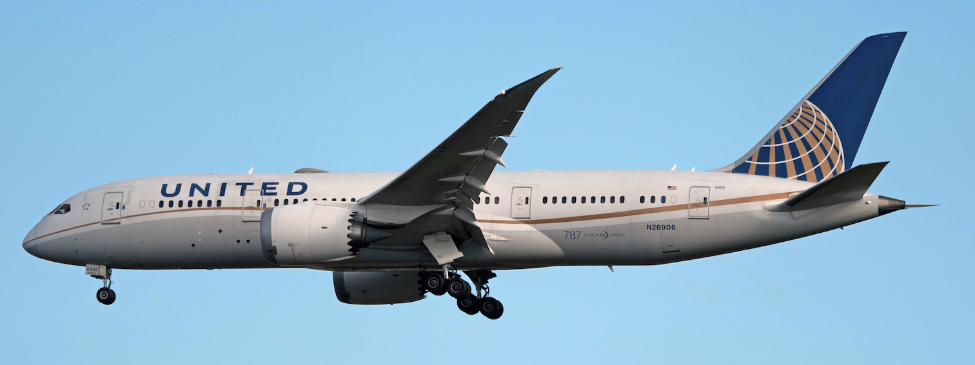

Figure 2. Critical Aircraft for Problem 1. Boeing 787-8 Dreamliner Landing at IAD Airport (A. Trani).

Problem 2 (30 Points)

For the airport configuration described in Problem 1, perform the following geometric design assessments. The critical aircraft is the Boeing 787-8 Dreamliners shown in Figure 2.

1. Determine the centerline distance between runway 6/24 and taxiway “Alpha”.
2. Determine the centerline distance between runway 14/32 and taxiway “Bravo”.
3. Will the 79-foot tall hangar be a problem to locate taxiway “Alpha”. Explain. Check violations for TSA and TOFA.
4. Locate five high-angle runway exits (as shown in Figure 3) to efficiently move landing aircraft on runway 6 to the airport terminal. The aircraft fleet mix is given on Table 2. Explain your rationale for packing the runway exits.
5. For part (d) estimate the runway occupancy time expected from your runway exit placement.
6. The airport client would like to know if a high-speed exit is necessary to process landings on runway 6. The peak hour landing rate is 15 aircraft per hour. Explain if you would consider a high-speed runway.
7. If a high-speed runway exit was to be constructed on runway 6/24, would would be the recommended separation between the runway and the taxiway centerline “Alpha”?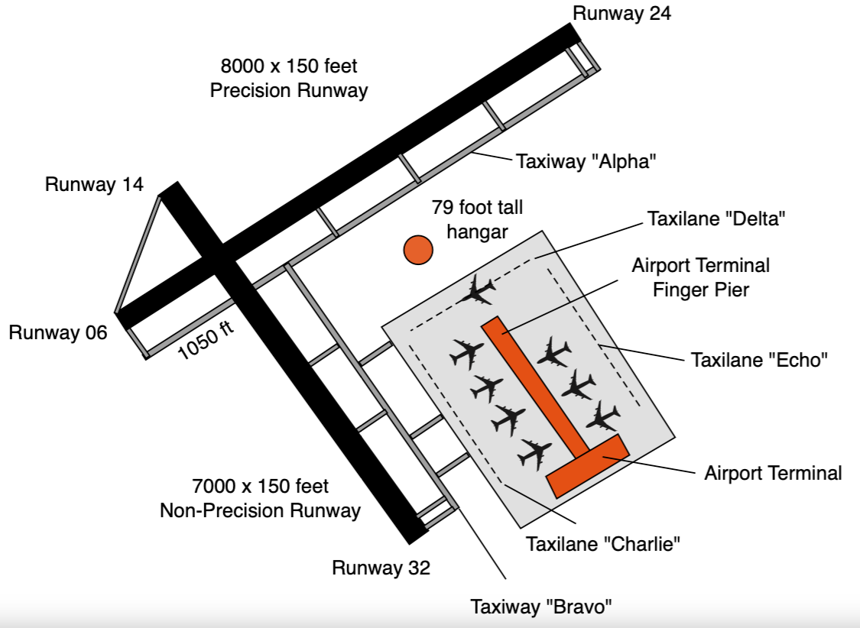

Figure 3. Airport Configuration for Problem 2.

Table 1. Aircraft Fleet Mix for Problem 1.

| **Aircraft ID** | **Aircraft** | **Fleet Mix (%)** |
| --- | --- | --- |
| **SR22** | Cirrus SR22 | 15 |
| **C680** | Cessna Latitude C680A | 10 |
| **A320** | Airbus A320 | 30 |
| **B738** | Boeing 737-800 | 35 |
| **B788** | Boeing 787-8 | 10 |
| **Totals** |  | 100 |

Problem 3 (40 Points)

Refer to the airport configuration shown in Figure 3 to answer the following questions.

1. Determine the length of the airport terminal finger pier designed to accommodate eight gates (four per side of the finger pier) with two Boeing 787-8 and six Boeing 737-800 parked simultaneously. Assume the width of the finger pier terminal element is 100 feet to accommodate eight departure gate lounges with plenty of seats for departing passengers. The client wants one wide-body aircraft gate on each side of the finger pier.
2. Determine the distance needed between taxiway “Bravo” and taxilane ‘Charlie”.
3. Determine the distance from the runway 14/32 centerline to the finger pier terminal considering the provision of parallel taxiway “Bravo” and parallel taxilane “Charlie”.
4. Draw to scale your solution for the airport terminal finger pier including the apron area with taxi lanes “Charlie”, “Echo” and “Delta” with eight boxes representative of the dimensions of the aircraft.

**Bonus Points (4):** Obtain the DXF files from the Boeing web site (<https://www.boeing.com/commercial/airports/3_view.page>) and draw your solution in part (d) using the actual aircraft shapes.