CEE 4674: Airport Planning and Design Spring 2015

**Quiz 2**

**Date: April 2, 2015**

**Instructor: Trani**

**Instructions**

Write your solutions in a single Word file and create a PDF file. Cut and Paste all your answers using screen captures. Show all your work. Label your file with your last name and CEE4674. Email your PDF solutions to my email address ([vuela@vt.edu](mailto:vuela@vt.edu)). In the email header use the words **CEE 4674 Quiz2**.

# Honor Code Pledge

The information provided in this exam is my own work. I have not received information from another person while doing this exam.

_____________________________________________________________ (your signature/name)

**Problem #1 (30 points)**

The wind observations contained in the companion file were collected several years ago at a rural location being considered as a potential airport site.

**a)** Using the information provided, estimate the best runway orientation for this location. The aircraft population operating at the airport will be single-engine and twin engine aircraft with Runway Design Codes A-I and BI.

b) Would a single runway satisfy the FAA runway coverage requirements? Briefly Comment.

**Problem # 2 (40 points)**

An airport located at sea level conditions has a single runway as shown in Figure 1. The airport serves three airlines operating medium size transport aircraft such as the Boeing 757 and Boeing 737-900. The runway is a precision runway with an instrument landing system (Cat 1) with RVR 2400 feet.

1. Estimate if the 181-foot antenna is an obstruction to navigation. If the antenna is an obstruction to navigation explain how will this affect the operations at the airport.

1. Using the declared distance concept, find the Landing Distance Available (LDA) for aircraft landing on runway 27. In your analysis provide full Runway Safety Area (RSA) protection as required by the FAA.
2. Find the Landing Distance Available (LDA) for aircraft landing on runway 09.

1. Find the Accelerate and Stop Distance Available (ASDA) while taking off on runway 27.
2. If an arrestor bed is installed at the runway threshold 09, estimate the size of the EMAS required and the benefit to LDA and ASDA estimated in parts (b) and (c) of this problem.

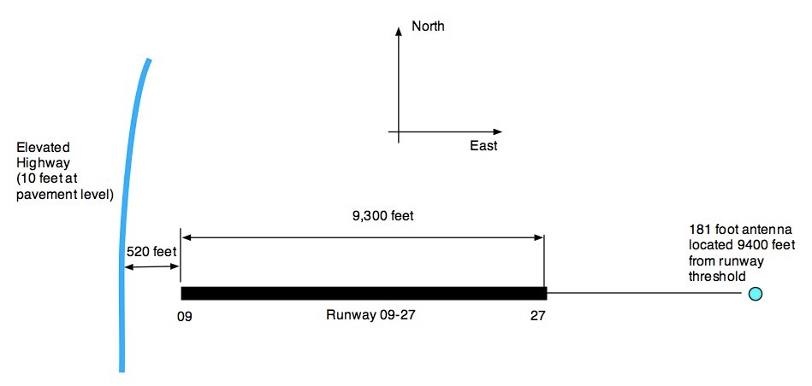

Figure 1. Runway Configuration for Problem 2.

**Problem #3 (30 points) - Short Answers**

a) Find the minimum taxiway width and taxiway shoulder width for a new taxiway at an airport serving Boeing 757-300 aircraft.

b) A new cargo airport in Colorado is located at 5,200 feet above sea level conditions. The airport is expected to have approaches with visibility minima of 1/2 mile or less. The largest aircraft serving the airport is an Airbus A380 freighter. Find the minimum distance required to construct a parallel taxiway.

c) For problem (b) perform the analysis considering taxiing and holding aircraft clear of the inner-transitional OFZ of the runway. In other words, if an Airbus A380 taxies on the taxiway will the tail of the aircraft penetrate the inner transitional OFZ?

d) A 6000-foot long runway for an airport exclusively used by General Aviation (GA) aircraft has two grades -0.76% and +0.64% with a point of intersection located 2,450 feet from the runway threshold. Find the length of the transition curve needed. Is the airport suitable for GA operations? Briefly explain.

1. Estimate the minimum distance between two terminal buildings if a dual-taxilane system is to be provided between the terminals in question. The critical aircraft is a Boeing 747-8. In your analysis, consider that Boeing 747-8 park at the gates on both terminals.

