CEE 4674: Airport Planning and Design Fall 2022

Quiz 1 - Take Home (Due October 12, 2022 via Canvas)
Open Notes and Internet
Instructor: A.A. Trani

Instructions

Create a solution file using the word processor of your choice. Convert to PDF and submit to Canvas. Include all screen captures of all your work including aircraft manufacturer’s tables and figures, FAA nomographs and others.

Honor Code Pledge
The information provided in this exam is my own work. I have not received information from another person while doing this exam.

_____________________________________________________________ (your signature/name)

Problem 1 (40 points)
Perform an assessment of the runway length for John Wayne Airport (SNA). Airlines operating at SNA use the Boeing 737-8 (Boeing 737-8 Max) with characteristics shown in Table 1. For this analysis, use the latest version of the Boeing 737-8 Max documents for airport design (Revision G published on May 2022).

Table 1. Aircraft Considered in the Runway Length Analysis of SNA. Picture Source: A.A. Trani.
Aircraft | Engine | Remarks
Boeing 737-8 (Max) with CFM LEAP-1B28B1 engines. Aircraft maximum design takeoff weight is 179,800 lb. 160 seats in a two-class layout.
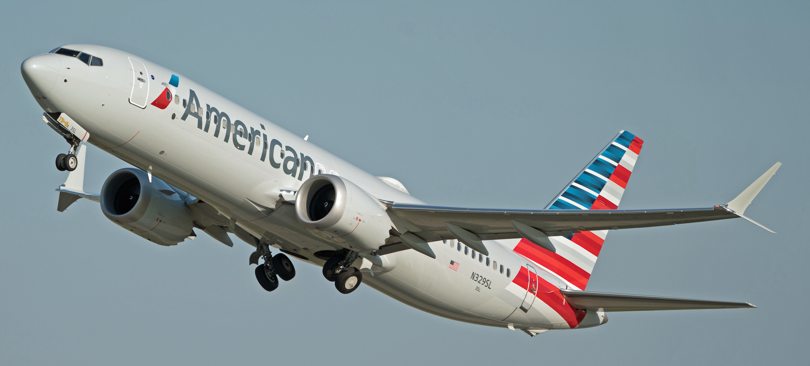

- Can the Boeing 737-8 Max operate from SNA in routes to Chicago (ORD) and Seattle-Tacoma (SEA) with 90% of the seats full at the airport design temperature? Show me all the steps in the analysis to estimate runway length for the critical route. Clearly state al your assumptions and show your intermediate calculations.
- Use Google Maps or Google Earth to examine the runway ends for the longest runway at SNA. Tell me if the airport complies with the Runway Safety Areas required. The critical aircraft is the Boeing 757-200.
- if the airport wants to expand services to Boston, estimate the new runway length needed using the Boeing 737-8 Max as the critical aircraft. In the analysis, assume the same 90% seats full.

Problem 2 (30 Points)
Use the Small Aircraft Runway Length Analysis Tool (SARLAT) to evaluate and improve an existing 4,900 foot long runway located at an airport 3,900 feet above mean sea level conditions. The average of the maximum daily temperatures of the hottest month of the year is 82 degrees F. The runway has a grade of 0.7%. The airport is expected to serve single, multi-engine piston, turboprop and jet powered aircraft (see Table 2).

Table 2. Aircraft Fleet Mix for Problem 2.
Aircraft Type | Aircraft | Percent of Fleet Mix (%)
Piston | Cessna 172 | 20
Piston | Cessna 402 | 10
Piston | Diamond Twin-Star | 10
Turboprop | Beechcraft King Air C90 | 10
Turboprop | Socata TBM 850 | 10
Jet | Cessna 560 560 XL | 10
Jet | Hond Jat 420 | 10
Jet | Cessna Citation I | 10
Jet | Embraer Phenom 300 | 10
Total |  | 100

- Is the existing runway length available suitable for corporate jet operations if the runway pavement is wet? Explain some of the constraints with numbers obtained in your analysis.
- Name the most critical aircraft operating at the airport.
- Find the runway extension needed in order to allow takeoffs with wet runway operations with at least 75% useful load for the most critical aircraft in the fleet.
- Find the runway extension needed in order to allow landing operations under Part 135 eligible with wet runway operations for all the aircraft in the fleet.
- Comparing solutions in parts © and (d), what is the recommended runway extension for the airport to satisfy both conditions?

Problem 3 (30 points)
True or false section.
Question | True / False
Runway 31L at JFK has a displaced threshold longer than 3,000 feet.
The Bombardier CRJ200 is a popular 70-seat regional aircraft.
The Douglas DC-8 was a popular turboprop-powered aircraft in the 1950s.
San Francisco runway 28L is a precision runway with medium intensity approach lights.
Part 135 refers to non-scheduled operations conducted by air taxi operators in the US.
A 70-knot exit speed EMAS designed for a Boeing 757-200 has a total length of 450 feet.
The ADG group for the Boeing 747-8 is V.
An aircraft with a 155 knot approach speed belongs to AAC group D.
Approach speeds used to designate AAC groups are measured at the minimum landing weight.
The taxiway design group for the Airbus A350-1000 is 5.
The route distance typically flown from Los Angeles International to Sidney (Australia) is 6,500 nautical miles.
In the year 2021, the number of arriving passengers to Bangor Maine exceeded 300,000.
In 2021, Spirit Airlines carried the largest number of passengers from Fort Lauderdale International Airport
Runway 1 threshold at DCA airport has a non-compliant RSA area (Boeing 757-200 is the critical aircraft).
A 30-foot tall hangar located 380 feet from the centerline of a runway violates the Runway Object Free Area.

