CEE 4674: Airport Planning and Design Spring 2016

**Quiz 1**

**Date: February 23, 2016**

**Instructor: Trani**

**Instructions**

Write your solutions in a single MSWord or PDF file. Cut and Paste all your answers using screen captures. Show all your work. Label your file with your last name and CEE4674. Create a PDF file and email your solutions to [vuela@vt.edu](mailto:vuela@vt.edu). In the email header use the words CEE 4674 Quiz.

# Honor Code Pledge

The information provided in this exam is my own work. I have not received information from another person while doing this exam.

_____________________________________________________________ (your signature/name)

# Problem #1 (40 points)

The Los Angeles Airport Authority is planning runway length improvements to runway 24L on the North side of the airport. The airport authority would like to improve runway 24L allowing airlines to conduct takeoffs supporting international cargo services to South America (a growing market). Estimate the runway extension needed for runway 06R/24L if the critical stage length service has been identified at this airport and shown in Table 1.

In your analysis use the latest version of the Boeing documents for airport design and design the runway according to Federal Aviation Regulations (F.A.R.). Add 5% to the distance calculated to account for real Air Traffic route conditions and to account for possible weather deviations from the shortest flight path. In your analysis, consider that cargo airlines would like to carry as much payload as possible.

Table 1. Critical Aircraft Used in the Redesign of LAX Runway 24L.

| Origin-Destination Airport Pair | Aircraft Flying the Route |
| --- | --- |
| LAX - EZE  Los Angeles to Buenos Aires International Airport (EZE) | Boeing 747-400ER Freighter with General Electric CF6-80C2B5F engines and a maximum takeoff weight of 910,000 *lbs*. |

a) Estimate the fuel load carried and desired takeoff weight to perform the trip LAX-EZE.

b) Find the runway length needed to conduct cargo operations in the proposed route. State the airport design temperature, airport elevation and other environmental conditions and assumptions used in your calculations. State the figure(s) used in the aircraft manufacturer documents.

c) What percent of the maximum structural cargo payload can the airline carry in the LAX-EZE route given your design in part (b) of the problem?

# Problem # 2 (30 points)

The airport shown in Figure 1 is the subject of the analysis in this problem. The airport serves two small commuter airlines operating Bombardier CRJ-200 and Embraer 145 aircraft. The runway is located 3,100 feet from a small building and for this reason a displaced threshold is provided.

1. Use the declared distance concept, find the Landing Distance Available (LDA) for aircraft landing on runway 33. In your analysis provide full **Runway Safety Area (RSA)** protection prior to the landing threshold and beyond the runway.

1. Find the Accelerate and Stop Distance Available (ASDA) while taking off on runway 33. In this analysis protect the RSA at the end of the departing runway.
2. Could an engineered materials arresting system help in this situation? Estimate the size of the EMAS needed and explain.

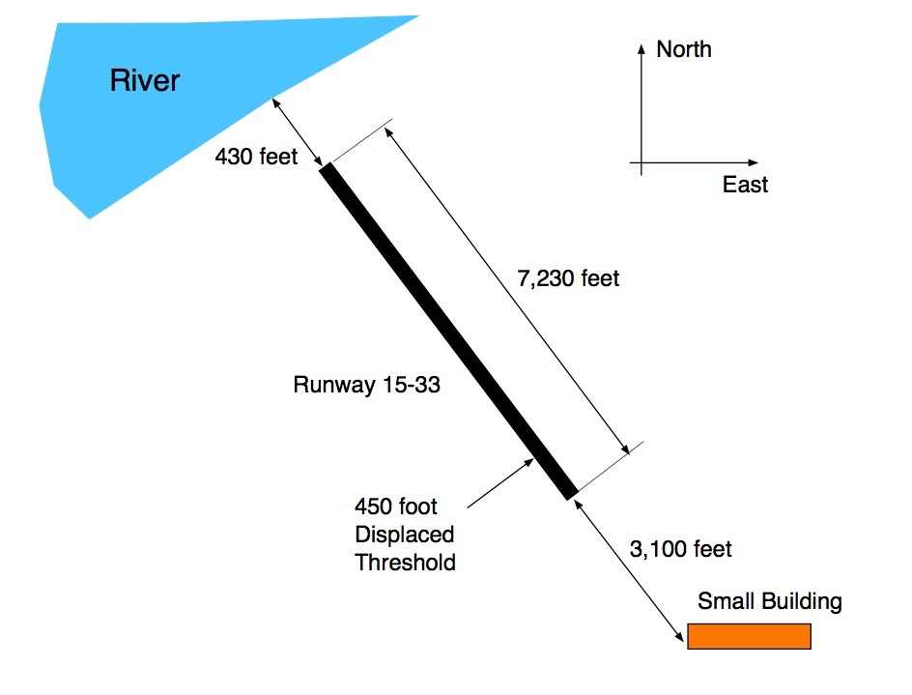

Figure 1. Runway Configuration for Problem 2.

# Problem #3 (30 points) - Short Answers

a) A new corporate aviation airport is designed to accommodate aircraft such as the Cessna Citation 680 Sovereign (shown below) and used as the critical aircraft. State **all the FAA design codes** used for runway and taxiway geometric design standards.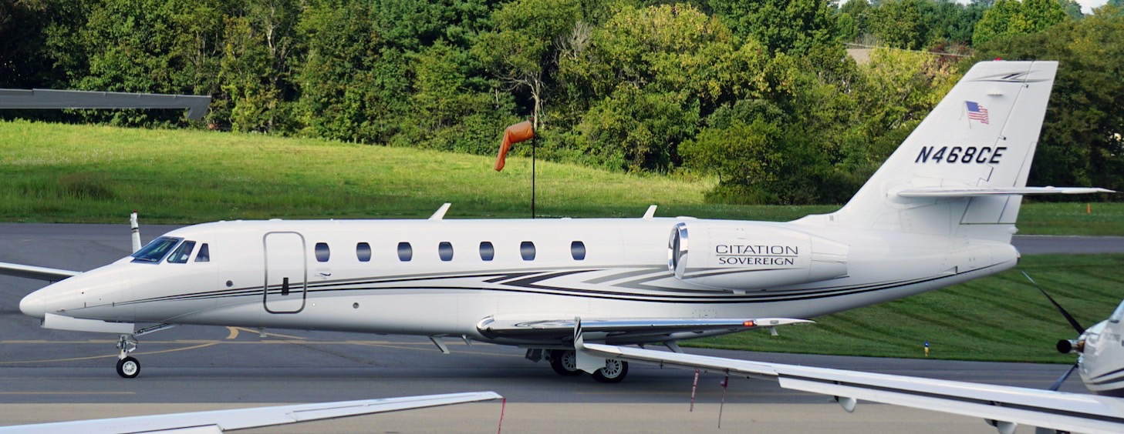

Figure 2. Cessna Citation Sovereign at Montgomery County Airport (A. Trani).

b) Could an airport with two parallel runways with runway centerlines located 2,700 feet apart and with a 200 foot stagger conduct simultaneous departures? Explain any ATC equipment needed for such operations.

c) Air traffic service that controls the airspace volume while aircraft descend through 9,000 feet at a location 25 nm from Washington Reagan Airport.

d) The following is a short description of an incident that happened on February 20, 2016. “A United Boeing 757-200, performing flight from San Francisco to Denver was on approach to Denver when the crew reported problems with the flaps and advised they would be **landing at a higher than normal speed**” (Aviation Herald, 2016).

Using the basic lift equation explain why would the aircraft have to land at “higher than normal landing speed” if the flaps cannot be deflected to their normal landing position.

f) Find the suitable runway length needed to accommodate light sport aircraft such as the Evektor-Aerotechnik EV-97 (see Figure 3) with a stalling speed of 40 knots. The runway will be at an airport located 4,510 feet above mean sea level conditions.

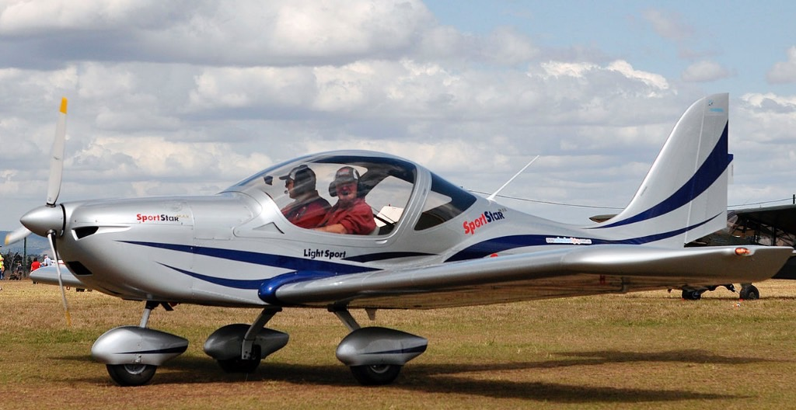

Figure 3. Evektor-Aerotechnik EV-97 (source: Wikipedia).