CEE 4674: Airport Planning and Design Fall 2022

**Final Exam for CEE 4674**

**Date Due: December 14, 2022 at midnight** Instructor: Trani

**Sign VT Honor Code Pledge**

**This exam is the product of my own work. I have not received help from anyone.**

**______________________________________________________________________________**

# Problem 1 (25 Points)

Evaluate runway length operations at San Diego International Airport (SAN) using the Boeing 787-9 (see picture below). The airline in question expects to fly to Tokyo Narita Airport and Seoul International Airports. Table 1 shows the specific aircraft for the airline.

Table 1. All Nippon Airways Boeing 787-9 Dreamliner Taxiing at Gimpo Airport (South Korea). Source: A. A. Trani.

| Aircraft Considered |
| --- |
| Boeing 787-9 with Rolls-Royce engines. Aircraft maximum design takeoff weight is 560,000 lb. 246 seats in a three-class layout. You can find the seating configurations of most airlines at SeatGuru (<https://www.seatguru.com/airlines/ANA/ANA_Boeing_787-9_V3.php>). |
|  |

1. Find the typical distance flown length between San Diego and the two proposed routes. Use the Great Circle Flight Path mapper link provided in our interesting web sites (<http://www.gcmap.com//>). Add 6% to the distances estimated by the Great Circle mapping application to account for real Air Traffic route conditions and to account for possible weather deviations.
2. Find the design temperature at San Diego. State the source of your data.
3. Find the Desired Takeoff Weight (DTW) to fly the critical route. Assume a 100% passenger load factor in your analysis (i.e., all seats are full). Clearly state the fuel weight, operating empty weight and payload carried. Use the passenger weights discussed in class.
4. Find the runway length needed for the aircraft operating the critical route. Determine if San Diego has enough runway length to support both flights.
5. If the runway length estimated in part (d) exceeds the runway length available at SAN, find the runway length extension needed to support the proposed flights.
6. If San Diego has enough runway to support the critical route, estimate the maximum cargo load (loaded in LD-3 containers in the belly of the aircraft) the aircraft can carry limited by the existing runway length at SAN.

## Problem 2 (25 Points)

The problem is to estimate delays for departures and arrivals for the airport configuration provided in Figure 1. The airport has an airport surveillance radar (ASR) and ADS-B surveillance to track aircraft up to 60 nautical miles form the airport site. The ADS-B system can update the position of aircraft every one second. Tables 2 through 4 show the technical parameters and the typical ATC separations at the airport under Instrument Meteorological Conditions (IMC). Three aircraft groups (of the nine groups included in the Consolidated Wake Categories defined by FAA) operate at the airport. The airport has the following technical parameters: a) in-trail delivery error of 18 seconds, b) probability of violation is 5%. Air traffic controllers direct traffic to intercept a final approach fix located 15 miles from the runway threshold. Arrivals follow in-trail after crossing the final approach fix. The airport aircraft mix, runway occupancy times and approach speeds are shown in Table 2.

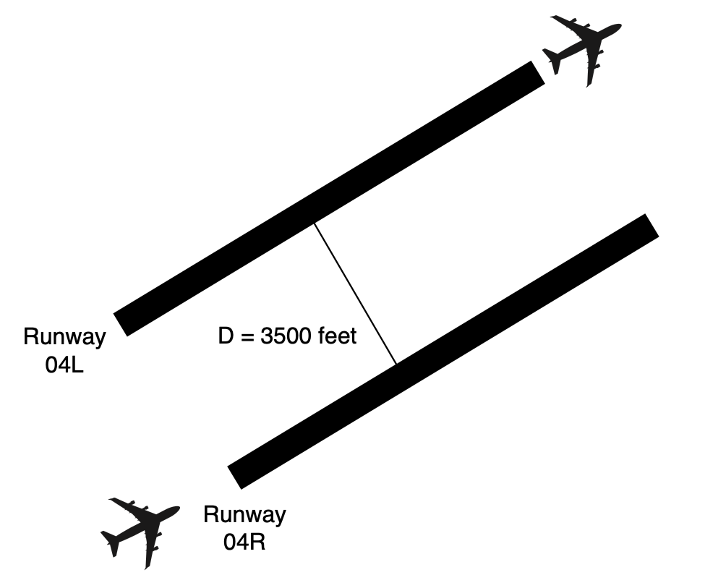

Figure 1. Runway Configuration for Problem 2.

You are allowed to modify the spreadsheet provided in class to solve the problem. Show me sample calculations for both opening and closing cases so that I know that you can do such calculations by hand.

1. Calculate the arrivals-only saturation capacity under IMC conditions.
2. Calculate the departures-only saturation capacity under IMC conditions.
3. Calculate the arrival-departure saturation capacity diagram (Pareto diagram) under IMC conditions.

Use Deterministic Queueing theory to estimate the total delay (in units aircraft-hours) to arriving aircraft for the configuration shown. You can use the MATLAB code provided in class. Show me the input parameters that you changed to solve the problem. Specifically:

1. Estimate the average delay (in minutes per arrival) for arrivals to runway 4R. Show how many arrivals are subject to delays.
2. Estimate the average delay for departures (in minutes per departure operation). Show how many departures are subject to delays.
3. Find the average queue length for the morning period.

Table 2. Runway Occupancy Times and Fleet Mix for Problem 3.

| **Aircraft RECAT Group** | **Percent Mix (%)** | **Runway Occupancy Time (s)** | **Typical Approach Speed (knots) from FAF** |
| --- | --- | --- | --- |
| F | 70 | 54 | 136 |
| E | 20 | 62 | 141 |
| B | 10 | 65 | 150 |
| Totals | 100 |  |  |

Table 3. Minimum arrival-arrival separations under IMC conditions. Values in are nautical miles. **Values Shown Do Not Include Buffers.** Full Table Available on Page 54 of Aircraft Classifications Handout.

|  | **Trailing Aircraft (Columns 2-5)** | | |
| --- | --- | --- | --- |
| **Lead (Column 1)** | **F** | **E** | **B** |
| **F** | 3 | 3 | 3 |
| **E** | 3 | 3 | 3 |
| **B** | 5 | 5 | 3 |

Table 4. Minimum departure-departure separations under IMC conditions. Values in are seconds. **ATC Buffers are Included.**

|  | **Trailing Aircraft (Columns 2-5)** | | |
| --- | --- | --- | --- |
| **Lead (Column 1)** | **F** | **E** | **B** |
| **F** | 75 | 75 | 75 |
| **E** | 90 | 75 | 75 |
| **B** | 125 | 125 | 125 |

Figure 3. Arrival Demand for Problem 3.

Figure 4. Departure Demand for Problem 3.

# Problem 3 (25 Points)

**True or false section.**

| **Question** | **True / False or Numerical Value** |
| --- | --- |
| The Airbus A330-900 belongs to Aircraft Design Group IV |  |
| High-speed runway exits are recommended if the runway has more than 15 operations per hour during the peak period. |  |
| The Boeing 707 was the first US commercial jet-powered aircraft. |  |
| Virginia Tech Airport is an airport that belongs to the National Plan for Integrated Airport Systems. |  |
| According to the consolidated wake turbulence criteria, the minimum separation between a Boeing 777-200LR (lead) and a Cessna 340 (following) is 6 nautical miles. |  |
| The Taxiway Design Group for the Boeing 787-10 is 5. |  |
| A 145-foot tall antenna located 7500 feet from the runway end and aligned with the extended runway centerline is an obstruction to navigation according to FAR Part 77. |  |
| Aircraft need more takeoff runway length under hot temperature conditions. |  |
| The length of runway safety area for a runway that serves Boeing 777-200LR is 700 feet. |  |
| According to Iowa State wind data, only 30% of the time winds at the Virginia Tech Airport are reported to be calm. |  |

# Problem 4 (25 Points)

**Quick Answers**

| **Question** | **Numerical Value** |
| --- | --- |
| Estimate the recommended EMAS system length for a Boeing 747 with gross weight of 875,000 lbs. Use the recommended runway exit speed in the analysis. |  |
| Find the recommended distance between a runway centerline and a parallel taxiway when high-speed runways are designed for the runway. The airport is located at an elevation of 800 feet above mean sea level conditions. |  |
| Estimate the distance between two parallel taxi lanes at an airport with ADG IV as the critical aircraft. |  |
| Estimate the dry takeoff runway length for an Embraer Phenom 300 operating from an airport located at 3,000 ft elevation and 80 degree temperature (no grade and no wind). Assume a 90% load factor. |  |
| Estimate a high-speed runway exit location allowing 75% of Boeing 737-900 class aircraft to exit under normal conditions at sea level. |  |
| Find the design crosswind component for the Airbus A220-300. |  |
| Estimate the wet takeoff runway length for a Beechcraft Baron 58 operating from a 1,500 ft airport elevation and 85-degree temperature (no grade and no wind). Assume 100% load factor. |  |
| Find the FAA recommended centerline radius of a high-speed exit for a Boeing 787-8 class aircraft. |  |