CEE 4674: Airport Planning and Design Fall 2026

Assignment 5: Runway Separations and Air Traffic Control

Date Due: October 3, 2025 (midnight) Instructor: Trani

Problem 1
Use Google Earth and Airnav (www.airnav.com) and your knowledge of runway separations, to answer the following short questions.
Fort Lauderdale-Hollywood International Airport (FLL)
- Can the airport conduct simultaneous approaches under IMC conditions? Name the runways that meet the requirement for simultaneous approaches.
- Comment on the runway configuration and the location of the airline gates at FLL.
Detroit International Airport (DTW)
2) Can the airport conduct simultaneous approaches in Instrument meteorological conditions? State the two runways that can offer enough separation to conduct simultaneous approaches at DTW. Briefly explain the FAA rule used and the distance between the runways in question.
Chicago O’Hare International Airport (ORD)
3) Can the airport conduct simultaneous approaches to runways 27R, 27C and 28C in instrument meteorological conditions? Briefly explain the rule used.

Problem 2
Use Google Earth and Webtrak (https://us.webtrak.aero/) to study runway operations at Fort Lauderdale-Hollywood International (FLL) and London Heathrow (LHR) Airports and answer the following questions. Figure 1 illustrates the annotated Webtrak interface to review historical airport operations.
1) Use Webtrak and observe the historical flights at FLL on August 26, 2026, starting at 10:00 AM local time. Observe traffic between 10:00 and 10:30 AM to understand the runway operations. 10:00 AM local time is hour 10 in Webtrak. You can speed up the replay of runway operations as needed.
- Use Google Earth to measure the distance between the parallel runways at FLL.
- Name the runways used for arrivals and departures in the period of interest.
- Based on your observations, can FLL do dual simultaneous arrivals? Name the runways used in such procedures.
- Briefly explain the FAA runway separation rule that applies and the distance between arrival runways in part (c).
2) Use Webtrak (https://webtrak.emsbk.com) and observe the historical flights at LHR between 3:00 and 3:30 PM on August 26, 2026 to understand the operations at the airport. 3:00 PM local time is hour 15 in Webtrak. You can speed up the replay of runway operations as needed.
- Use Google Earth to measure the distance between the parallel runways at LHR.
- Name the runways used for arrival and departure operations in the period of interest.
- Based on your observations, can LHR do dual simultaneous arrivals (recall LHR operates under ICAO rules)? Name the runways used in such procedures.
- Compare and contrast the runway operations at FLL and LHR. Explain the differences and similarities observed.

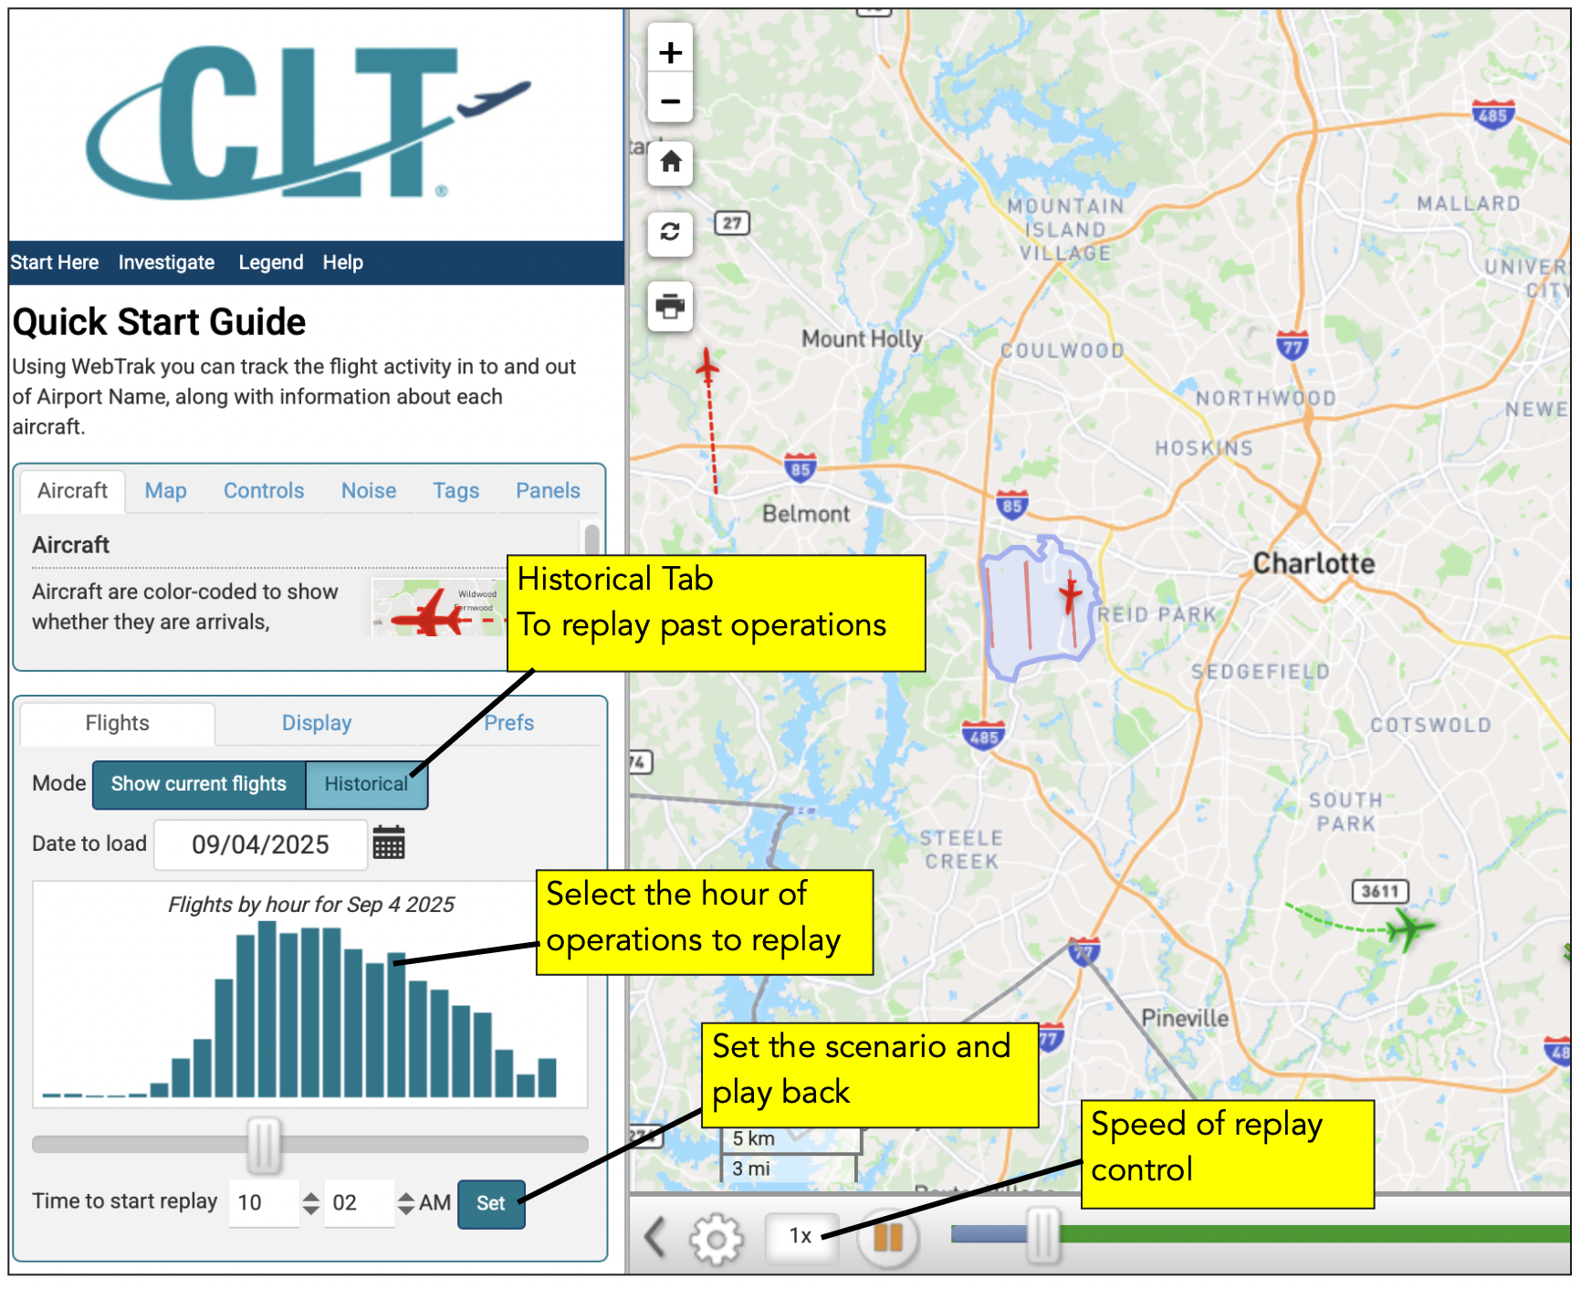
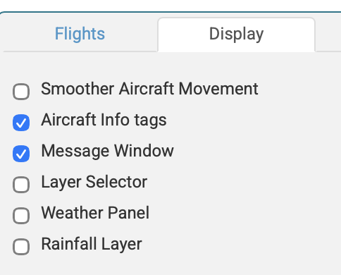
Figure 1. Annotated Webtrak Interface (CLT Airport). The bottom Figure shows the display controls to see the aircraft information tags.

Problem 3
Briefly answer the following questions with two sentences.
- Explain why the US is likely to keep airport surveillance radars operational in the future.
- Explain two differences between airport surveillance radars and ADS-B technology.
- Explain why, under older runway separation rules, runway separations at higher elevation airports increase compared to airports below 2,000 feet.
- Explain the difference in ATC-pilot communications between air traffic control in the domestic airspace and over oceanic airspace.
- An Airbus A220-300 (see Figure 2) flies from New York Kennedy Airport to Seattle. State three possible cruise altitudes for this flight. Explain the reason of your choice.
- Are departures on runway 26L and arrivals on runway 30 at Miami International Airport (LAS) subject to converging runway operations (CRO)? Explain the issue with CRO operations and the rule to identify when CRO applies.
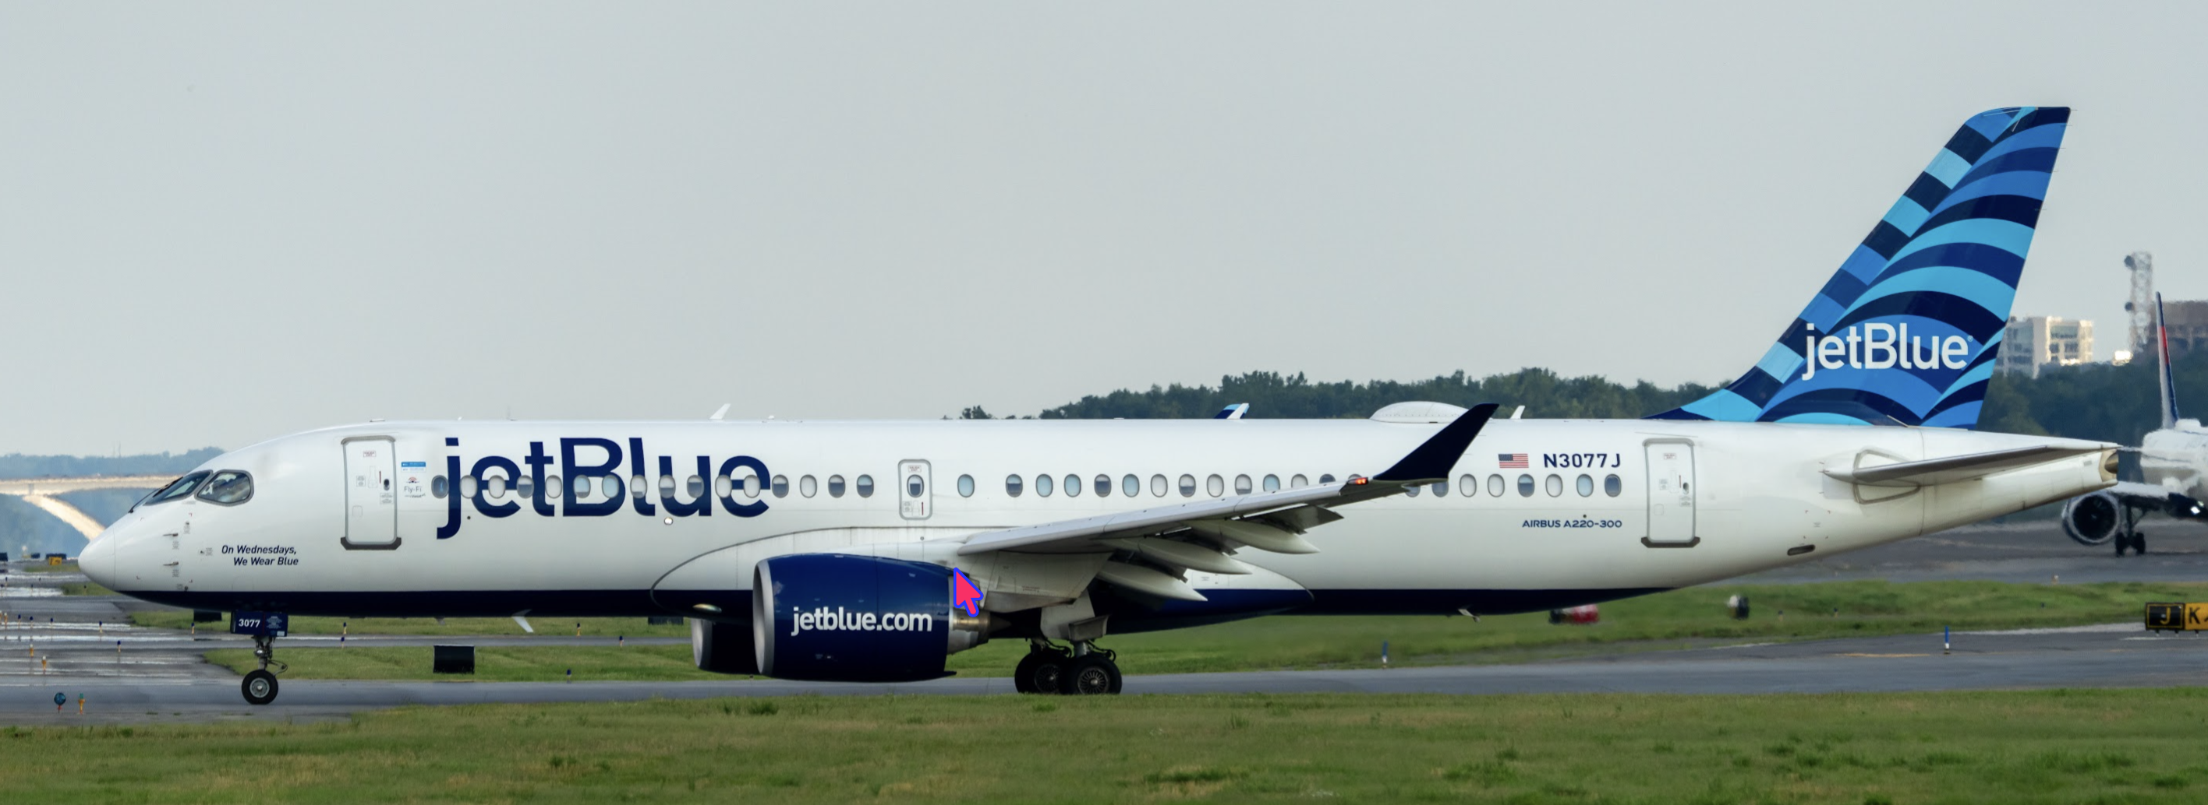
Figure 2. Airbus A220-300. Source: A. Trani.

Problem 4

In late March 2026, the FAA discontinued the use of Simultaneous Offset Instrument Approaches at San Francisco International Airport. The suspension of SOIA procedures reduces the airport arrival capacity from 54 to 36 per hour. Starting August 13, 2026, the FAA reintroduced a new form of staggered approaches to runways 28L and 28R. Read the article https://sfist.com/2026/08/12/faa-announces-new-landing-procedure-to-speed-up-arrivals-at-sfo/
- Explain the changes in hourly capacity with the new staggered procedures quoted in the article.
- Briefly explain the rationale for the suspension of the SOIA procedures that operated for more than twenty years without accident.
Use Webtrak (https://webtrak.emsbk.com) and observe the historical flights at SFO between 11:00 and 11:30 AM on September 9, 2026, to understand the new staggered operations at the airport. You can speed up the replay of runway operations as needed.
- Describe the new staggered operations.
- Use the Webtrak map scale to estimate the diagonal distance between two pairs of random staggered arrivals to runways 28R and 28L. Report the results indicating the type of aircraft involved.
- Knowing that aircraft wakes can travel laterally in windy conditions, what is your opinion about possible wake encounters with the new procedure.

