CEE 4674: Airport Planning and Design Fall 2026

Assignment 4
Date Due: September 26, 2026 Instructor: Trani

Problem 1
Before solving this problem, familiarize yourself with the FAA AC 150/5220-22B and review the course notes.
An airport is evaluating the need for a runway arrestor system (EMAS). The airport has two grassy areas on both sides of a runway (see Figure 1). The critical aircraft is the Boeing 757-200 also shown in Figure 1. The airport has instrument approach procedures with runway visibility minima lower than 3/4 of a mile but not lower than 1/2 mile (RVR). The airport is located at an elevation 1,200 feet above mean sea level conditions.
- Find the RDC code for the runway design to accommodate the Boeing 757-200. State all three parameters of RDC.
- State the dimensions of the RSA, ROFA, and RPZ for the Boeing 757-200.Draw to scale in the CAD software of your choice the three surfaces above. Comment on the relative dimensions.
- Find the size of the EMAS required to bring the runway end into compliance (i.e., to have a legal RSA) on both runway ends. State the recommended design exit speed used in your design. Comment if both runway ends can be made compliant with safety standards installing EMAS.
- State the dimensions of the OFZ surfaces associated with the runway (including the POFZ).
- Find the Inner Approach OFZ surface is violated by the passing trucks on the two-lane road on the runway end 09. Tell me the critical height of the vehicle on the highway. Show your calculations.
- Find if the proposed distance D violates the ROFA or the Inner Transitional OFZ.

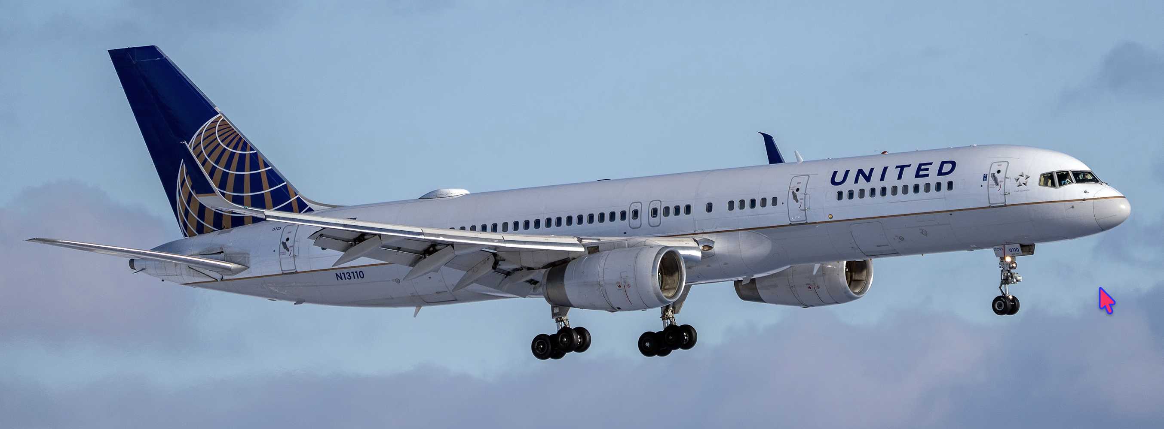
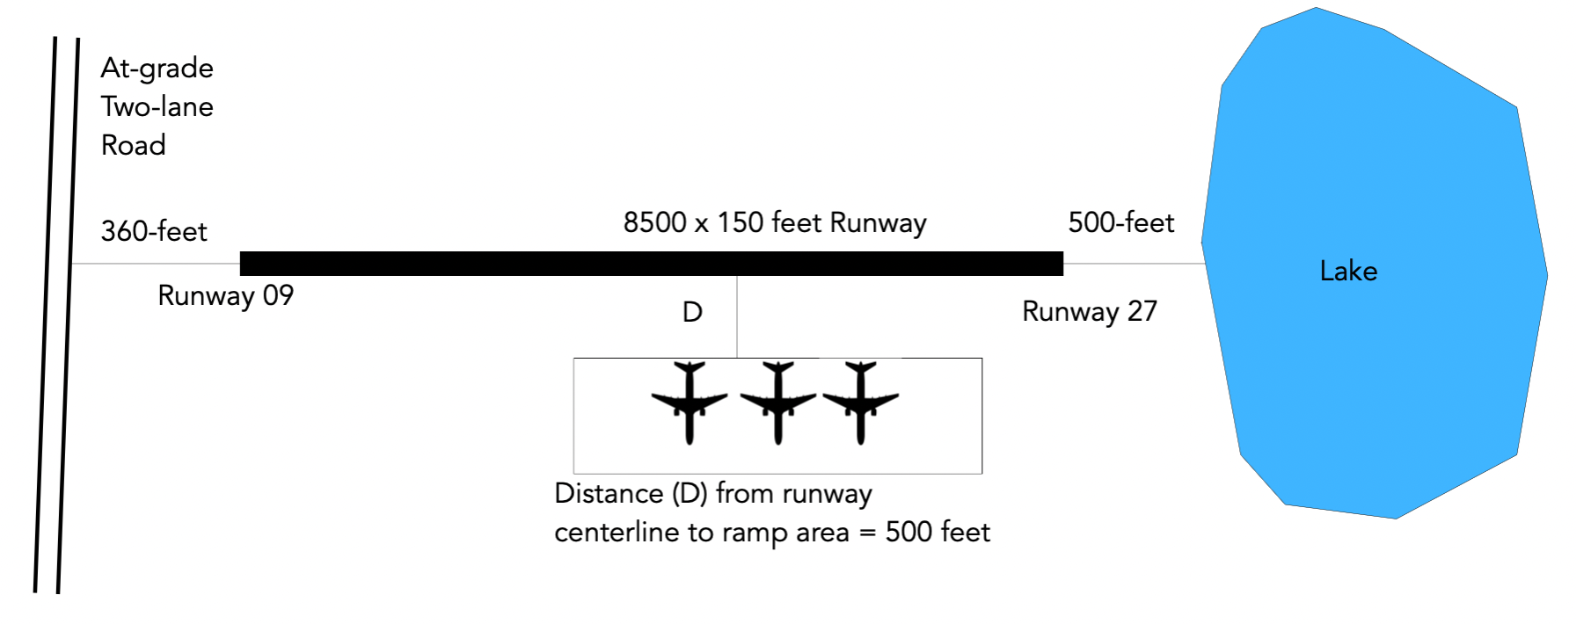
Figure 1. Boeing 757-200 Landing at CLE Airport (top) and Runway Graphic for Problem 1. Source: A. Trani.

Problem 2
Use Google Earth and FAA airport diagrams to examine runway and taxiway geometric features and provide brief answers.
- Study the Northside airport diagram for Atlanta Hartsfield-Jackson Airport. Airport diagrams can be obtained at : https://www.faa.gov/airports/runway_safety/diagrams/ (link available on the interesting web sites). A section of the airport diagram is shown in Figure 2.
- Use Google Earth to create an elevation profile starting at the end of runway 08R and moving West to include the taxiway V (Victor). Show the profile in your solution.
- Estimate the tallest aircraft tail height that can use taxiway V (Victor) without violating the Inner Approach OFZ surface at the runway 08R end (see Figure 2). Show your calculations. State the runway elevation at threshold 08R and how me the elevation at the centerline of taxiway V (Victor).
- Based on your calculations in part (c), what is the largest ADG group that can be accommodated on the End Around taxiway without violating the Inner Approach OFZ surface on runway 08R.
- Explain in simple words the value of End Around Taxiways at airports like Atlanta.
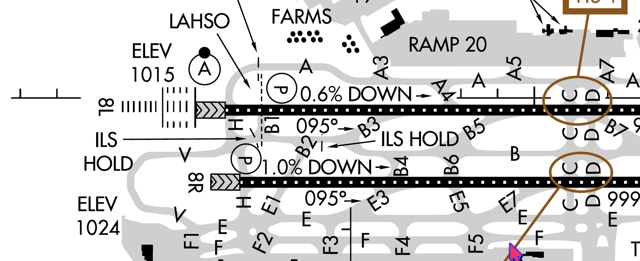
Figure 2. Airport Diagram of the North side of Atlanta Hartsfield International Airport (Source: FAA).

Problem 3
Use Google Earth and familiarize yourself with Cleveland Hopkins Airport (see Figure 3). Use Google Earth to measure distances and make comments about the design features.
- The Bombardier CRJ-200 is the critical aircraft to operate on runway 10-28 (see Figure 3). The runway can operate at lower than 3/4 mile but not lower than 1/2 miles visibility. Determine the size of the runway RSA area on both runway ends.
- Explain the rationale of the EMAS systems installed on both runway ends.
- Find the maximum runway end departure speeds on each end to stop the CRJ-200 within the EMAS dimensions.
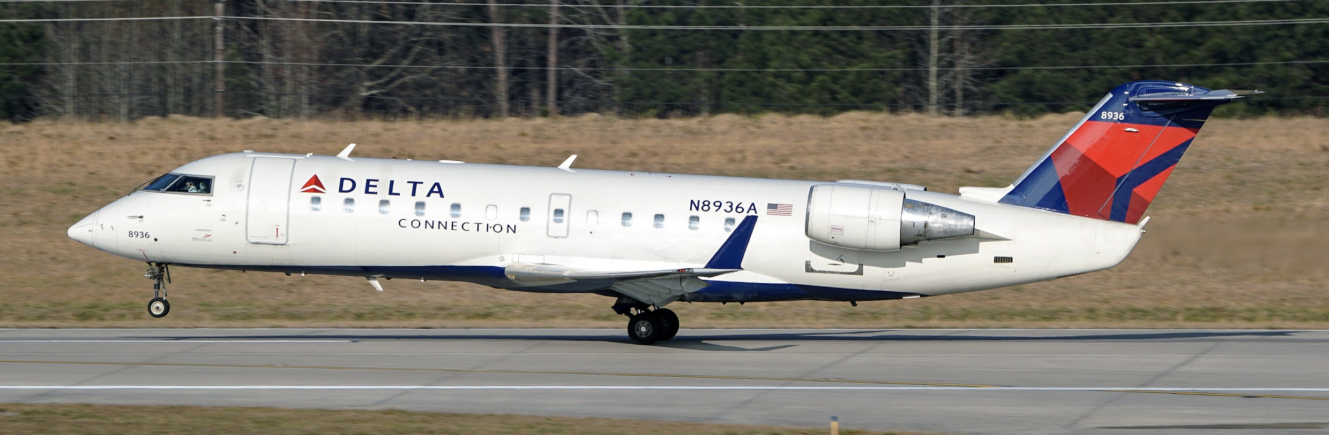
Figure 3. Bombardier CRJ-200 Departs RDU. Source: A. Trani.

Problem 4
Short answers. Show your calculations.
Question | Answer
Estimate the hydroplaning speed of a Boeing 787-9 using Horner’s equation. Use the nose gear tire pressure in your calculations (consult Section 7 of the Boeing 787 Airplane Characteristics for Airport Planning document).
Find the width of the Runway OFZ for small aircraft (< 12,500 lbs.)
ROFA dimensions for a runway designed for the Beechcraft King Air B350ER. Visibility is not lower than 3/4 of a mile. State all three dimensions.
Estimate the maximum speed that a Boeing 757-200 can depart the runway end 31 at LGA and come to a full stop using the existing EMAS system.
Horizontal distance from the runway centerline to the point of intersection of the horizontal surface (150 feet) and the inner transitional surface for a runway designed for a Boeing 747-8i at an airport elevation 2,300 feet. Visibility minima is lower than 1/2 mile.

