CEE 4674: Airport Planning and Design Fall 2026

Assignment 3: Runway Length Calculations for Large Aircraft
Date Due: September 19, 2026 Instructor: Trani

Problem 1
a) Estimate the desired takeoff weight for an Embraer 145LR (see Figure 1) carrying 47 passengers and operating from an airport located at elevation of 2,500 feet. The airline operator would like to fly 1,200 nm which includes the route detour factor. The 145LR is powered by the Rolls-Royce/Allison AE3007-A1 engine. Use the average passenger weight suggested in class in your calculations. In your analysis, use the Embraer E-145 document APM-145/1100 REVISION 16 - 29 NOVEMBER 2024.
Embraer 145XR landing at CLT Runway 18R.
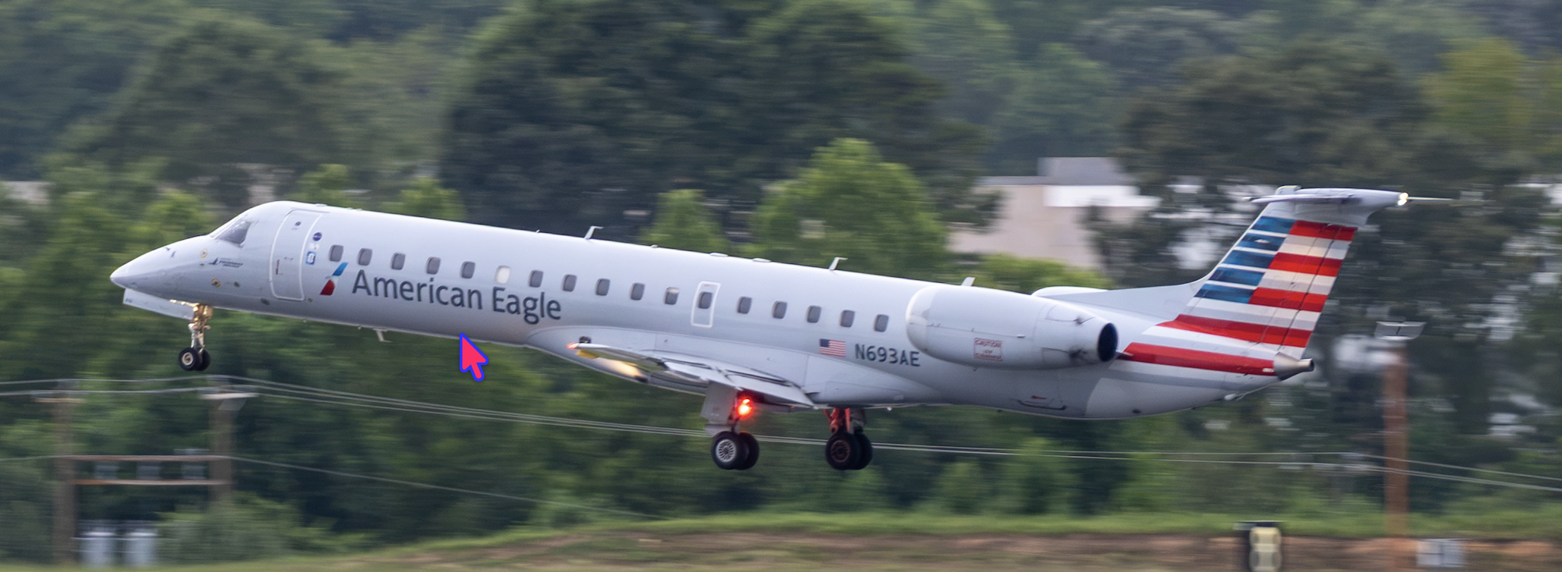
Figure 1. Embraer 145XR landing at CLT Runway 18R. Source: A. A. Trani.

b) Find the Takeoff Field Length for the Embraer 145LR described in (a) if the aircraft departs the airport with a design temperature is 25 deg. Centigrade. State the figure(s) used in your calculations.
c) For the takeoff conditions above, state the takeoff flap setting used.
d) For the same Embraer 145LR, find the landing field length landing at the maximum landing weight. State the landing flap setting used. State the figure(s) used in your calculations.
e) For the 1,200 nm trip described above, estimate the fuel carried in the flight.

Problem 2
Estimate the runway length required to operate an Airbus A330-900 (see Figure 2) from a new international airport. The client requires the Airbus A330-900 to operate at maximum takeoff weight of 251,000 kgs. The design temperature at the airport is ISA +15 degrees Celsius. The airport elevation is 1,000 feet above mean sea level. The characteristics of the Airbus 330-900 can be found in the Airbus Documents for Airport Design (https://aircraft.airbus.com/en/customer-care/fleet-wide-care/airport-operations-and-aircraft-characteristics/aircraft-characteristics). The latest document for the Airbus A330-900 is Revision No. 34 - Dec 01/25.
Airbus A330-900 with Trent 7000 engines. The aircraft maximum takeoff weight is 251,000 kgs. The seating configuration is 280 seats.
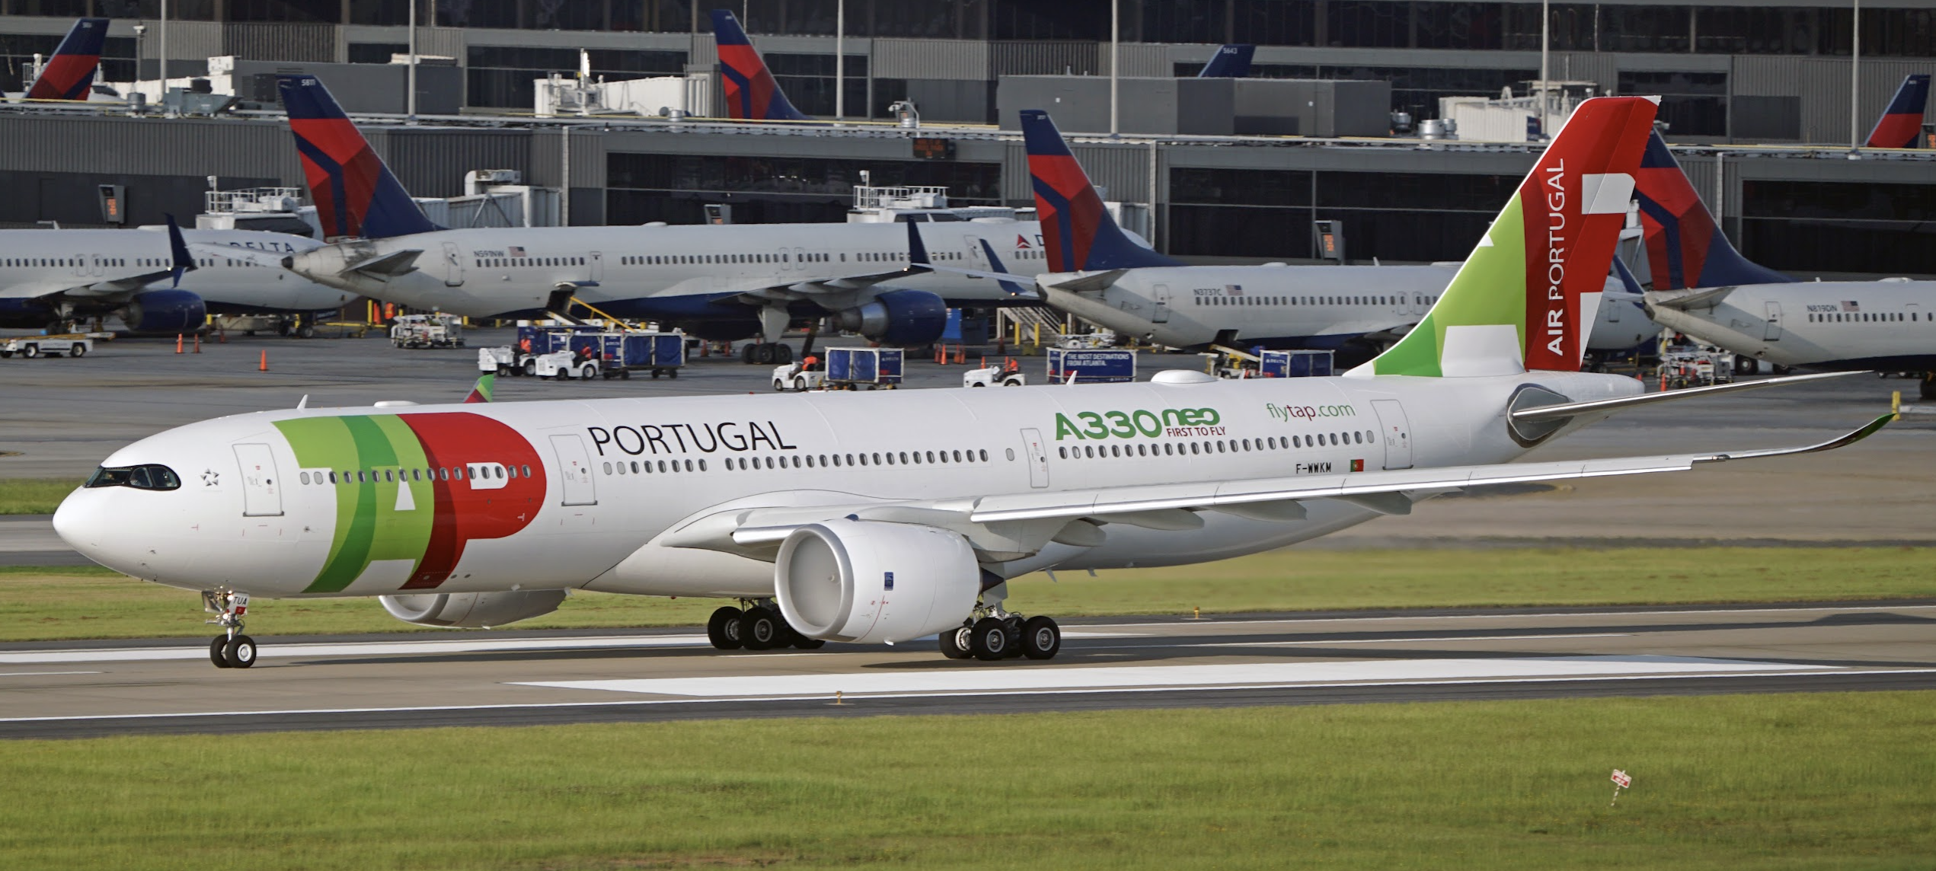
Figure 2. Airbus 330-900 at Atlanta Hartsfield-Jackson Airport. Source: A. A. Trani.

- Find the runway length needed to operate the Airbus A330-900 at maximum takeoff weight from the new airport under ISA +15 degrees Celsius conditions.
- State the design temperature for part (a) in degrees Celsius.
- Find the runway length needed to operate the Airbus A330-900 at maximum takeoff weight from the new airport under ISA temperature conditions.
- Compare the two solutions above. Briefly explain the changes in runway length as the design temperature changes.
- If an airline operates the Airbus A330-900 at maximum takeoff weight in ISA temperature conditions, find the longest route that can be flown with all seats full and additional 15,000 lbs. of belly cargo.

Problem 3
The airport authority of Denver International Airport (DEN) wants to build a third parallel runway to the north of runway 26. The objective of this analysis is to determine the length of the new runway allowing Boeing 787-10 (see picture below) operations from Denver using the design temperature. Use the latest Boeing 787-10 data provided by Boeing (see document in Figure 3).
The design temperature at the site can be found using the Climate Explorer web site. For this analysis use the historical temperature. If you need to find the International Standard Atmospheric (ISA) values, you can use the table in the notes (you need to interpolate) or use a web site like Digital Dutch to facilitate the analysis (https://www.digitaldutch.com/atmoscalc/).
Boeing 787-10 with Rolls-Royce Typical Engines engines. The aircraft maximum design takeoff weight is 574,000 lbs. The airline uses an aircraft with 330 seats in a two-class layout. Assume the Operating Empty Weight is 300,000 lbs. (the lowest value in the y-axis of the the payload range diagram).
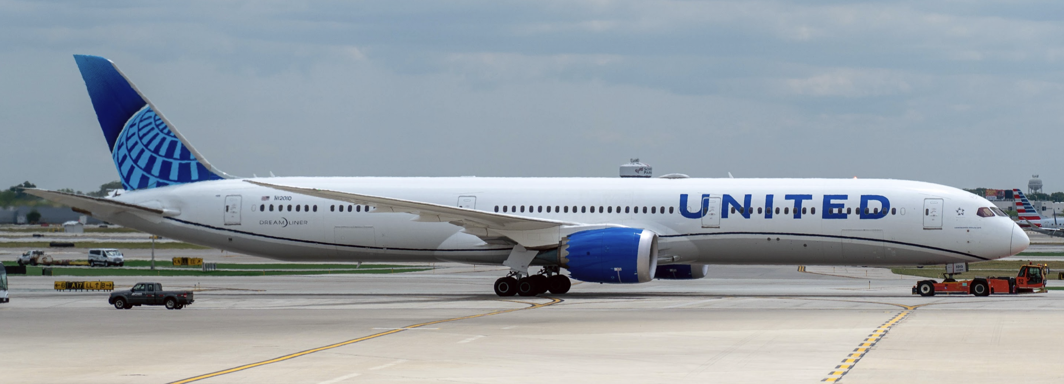

Figure 3. Boeing 787-10 in tow at ORD Airport. Source: A. A. Trani.

- Find the maximum takeoff weight for the Boeing 787-10 at Denver airport using the design temperature. Clearly indicate the figure used in the Boeing document. Also indicate the practical constraint that limits the Boeing 787-10 takeoff weight while operating at Denver.
- Using the design constrain in part (a), find the recommended runway length needed to operate the Boeing 787-10.
- Using the maximum takeoff weight found in part (a), find the longest route distance (in nautical miles) that can be flown with all seats full.
- If the same aircraft operates from Denver at the average annual temperature (year 2025), find the longest route that can be flown with all seats full. Comment on the differences observed between parts (c) and (d).

