CEE 4674: Airport Planning and Design Fall 2026

Assignment 2: Runway Length Analysis for Small Aircraft
Date Due: September 11, 2026 Instructor: Trani
Reading Assignment: Review Chapters 1 and 2 of the FAA Advisory Circular 150/5325-4b. Also, review the course notes on aircraft runway length estimation (http://128.173.204.63/cee4674/cee4674_pub/runway_calculations_Aircraft_upTo_60000lbs.pdf).
To do this homework, you need to download and install the Small Aircraft Runway Length Analysis Tool (SARLAT version 2.0.1) per instructions provided in Canvas.

Problem 1
Use the critical aircraft for runway length using the Small Aircraft Runway Length Analysis Tool (SARLAT) to design a runway at an airport located 3,010 feet above mean sea level conditions. The mean maximum daily temperature of the hottest month of the year is 86 degrees Fahrenheit. Table 1 shows the representative aircraft at the airport.
- Find the critical aircraft for runway length to satisfy the fleet mix runway performance requirements in Table 1. Assume no Part 135 operations at the airport.
List the following runway lengths for the critical aircraft for runway length:
  - Dry runway for takeoff distance
  - Wet runway for landing distance
These are the distances the FAA Airport Improvement Program (AIP) supports in runway improvement projects.
Provide your recommended runway length to serve the fleet mix in Table 1. The recommended runway length should be rounded to the nearest 100 feet (if the answer is above 30 feet).
- Show the SARLAT bar chart and output table of runway length requirements for all aircraft considered in the analysis.
- Find the maximum distance that can be flown (called mission distance) with the Embraer Phenom 300 operated at the desired useful load of 80% (takeoff) with the average passenger load of four passengers and two pilots. Use the runway length found in Part (a) for the critical aircraft.
- For the Cessna Citation M2, find the percent of the flights that can be flown using the runway length found in Part (a).
- Repeat the analysis in Part (a) using the average annual temperature at the airport (72 degrees Fahrenheit). Is the critical aircraft for runway length the same? Comment.
- The airport manager would like to know the runway length requirements if the Phenom 300 and the Cessna Citation M2 are operated under Part 135 rules (for landing). Run the analysis using the design temperature (86 degrees Fahrenheit) and comment on the runway length requirements considering Part 135 operational rules.

Table 1. Aircraft Fleet Mix for Problem 1.
Aircraft Type | Aircraft | Takeoff Useful Load (%) | Annual Operations | Picture
Piston | Cessna 182 | 100 | 5,600 | 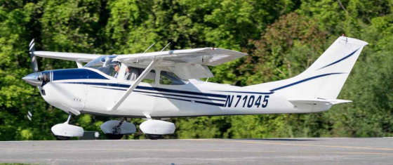
Piston | Beech Baron 55 | 100 | 1,350 | 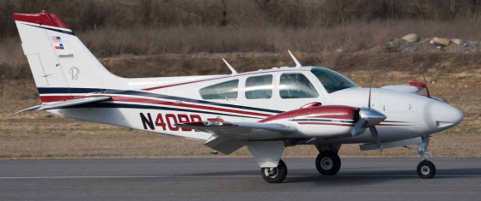
Piston | Cessna 340 | 100 | 530 | 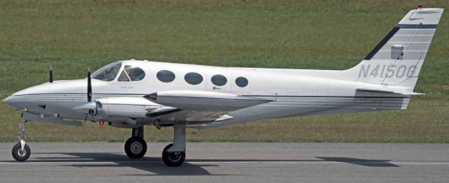
Turboprop | Beechcraft King Air B200 | 90 | 560 | 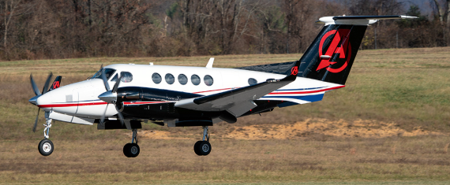
Turboprop | Pilatus PC12 | 100 | 560 | 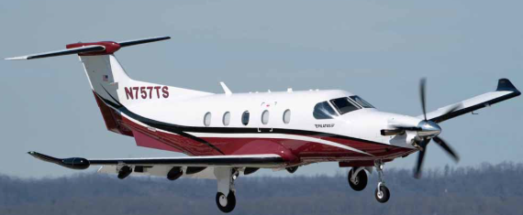
Jet | Cessna Citation M2 | 80 | 460 | 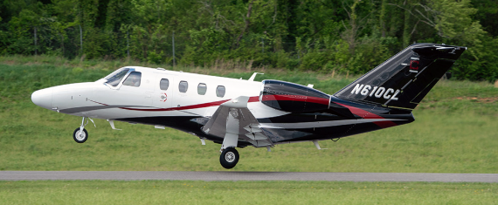
Jet | Embraer Phenom 300 | 80 | 395 | 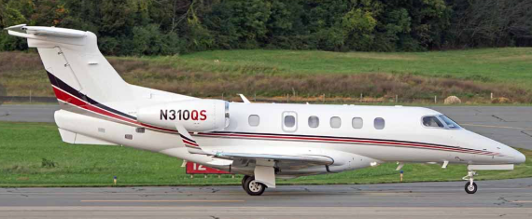

Problem 2
Use the Small Aircraft Runway Length Analysis Tool (SARLAT) to evaluate the existing runway at Richmond-Chesterfield Executive Airport (FCI) in Virginia. Table 2 shows a simplified aircraft fleet mix operating at the airport.
Task 1
Use airnav.com to summarize the following information for the airport:
  - Longest runway length available
  - Airfield elevation
  - Runway gradient (use the two published runway end elevations to make your calculation)
Task 2
Use the Climate Explorer website to estimate the design temperature conditions for the airport. The link to the Climate Explorer is on our interesting web site page (http://128.173.204.63/cee5614/sites_ce_5614.html#Weather). Use the temperature profile for Richmond (the closest metropolitan area to FCI).
  - Find the historical maximum daily temperature for the hottest month of the year.
  - In a separate section of your analysis, consider future climate change effects (i.e., higher emissions) to find the future design temperature. Use the temperature profile for years 2035-2065.
Table 2. Existing Aircraft Fleet Mix for Problem 2.
Aircraft Type | Aircraft | Annual Departures / Arrivals | Picture
Piston | Cessna 172 | 5,870 | 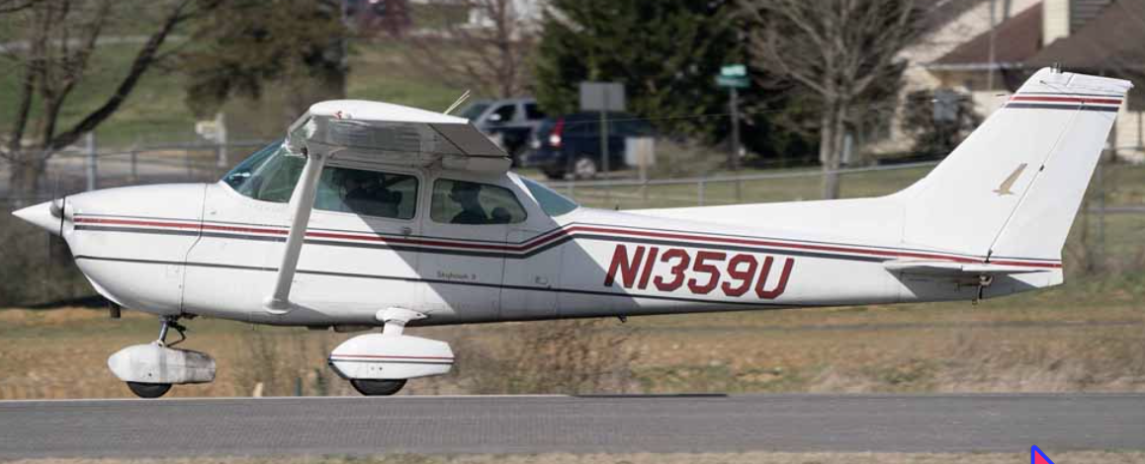
Piston | Piper Cherokee 161 | 4,800 | 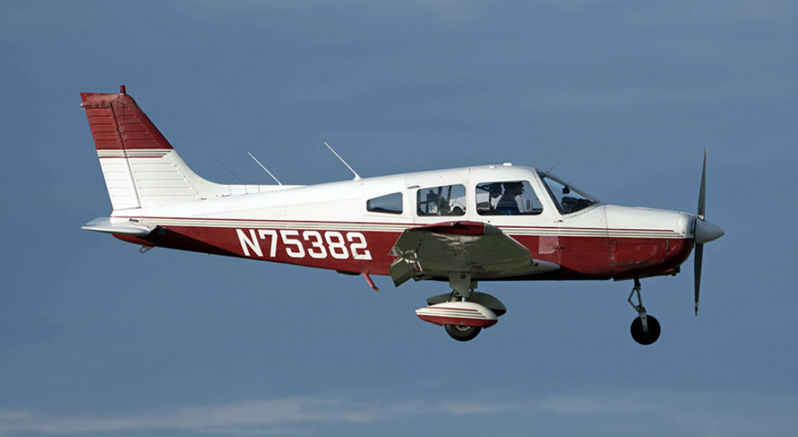
Piston | Cirrus SR22 | 2,400 | 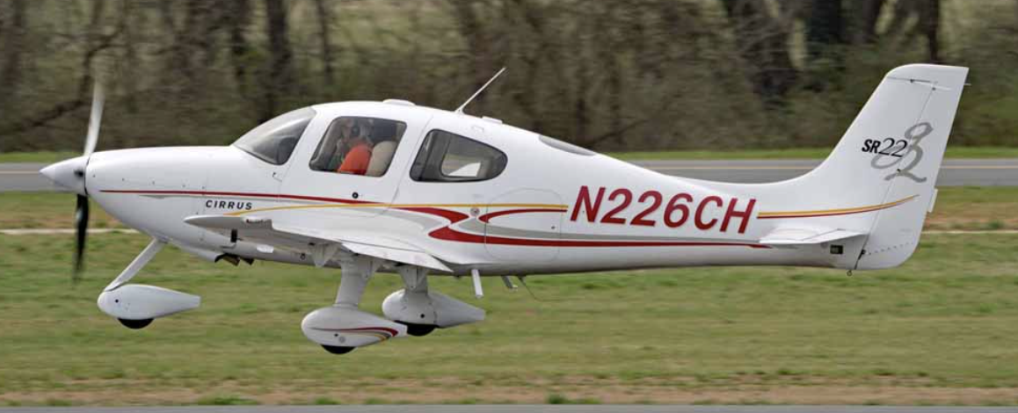
Piston | Cessna 421 | 460 | 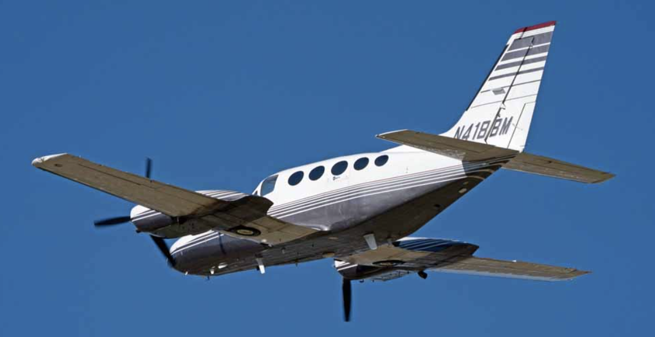
Turboprop | King Air B350ER | 1130 | 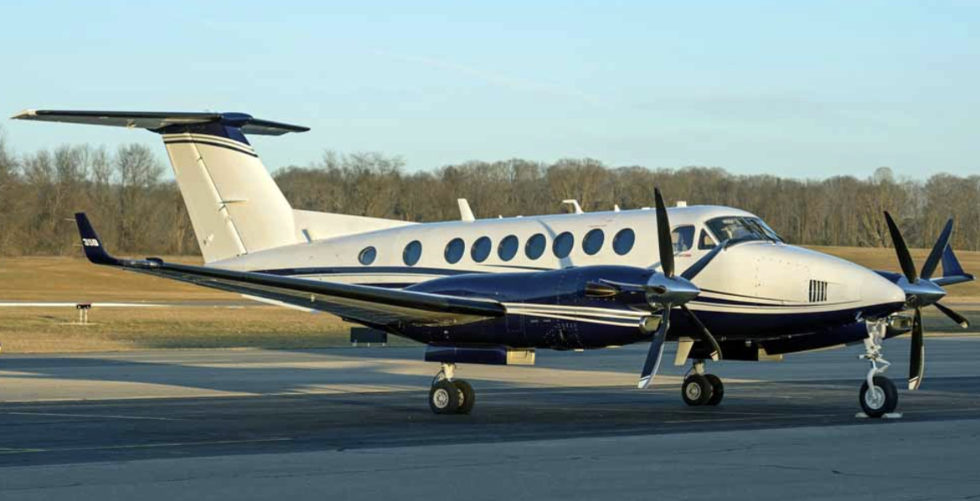
Turboprop | Pilatus PC12 | 870 | 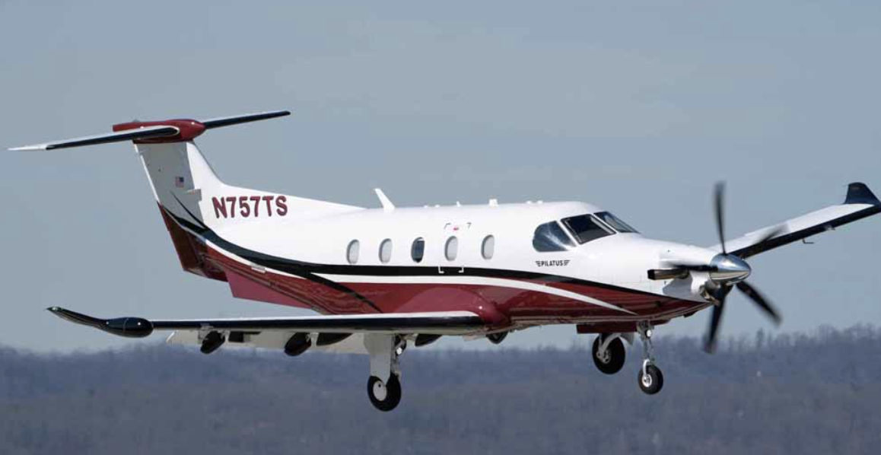
Turboprop | Socata TBM 850 | 320 | 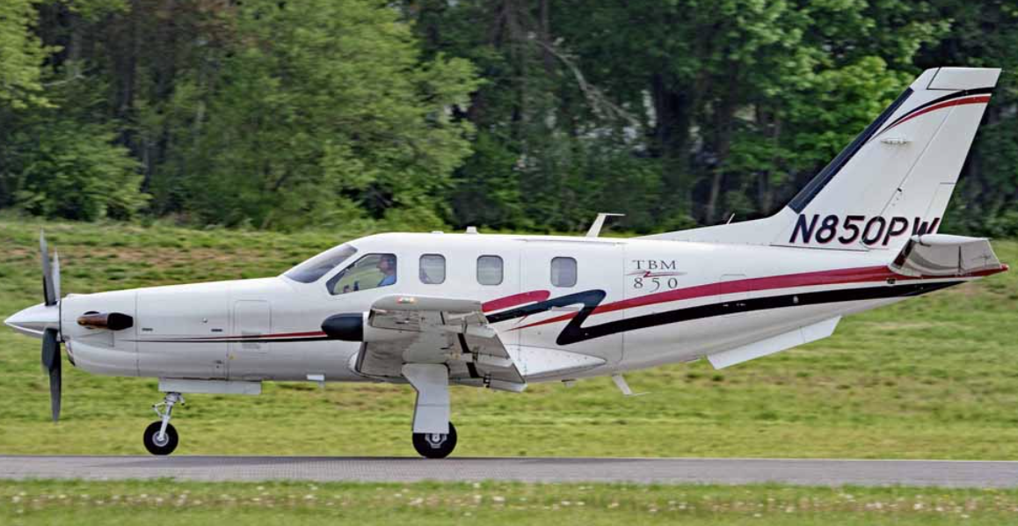
Jet | Cirrus SF50 | 1020 | 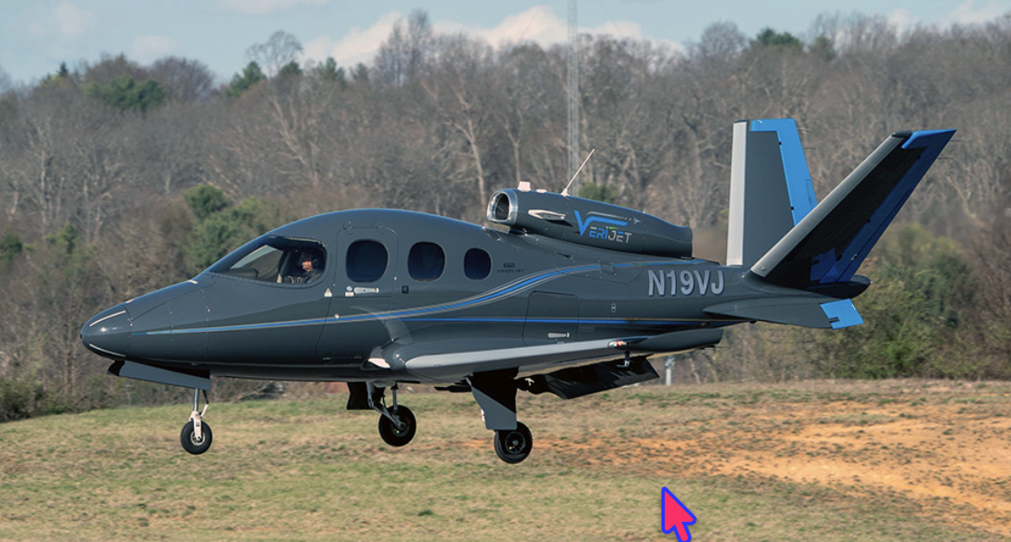
Jet | Cessna Citation 560XLS | 960 | 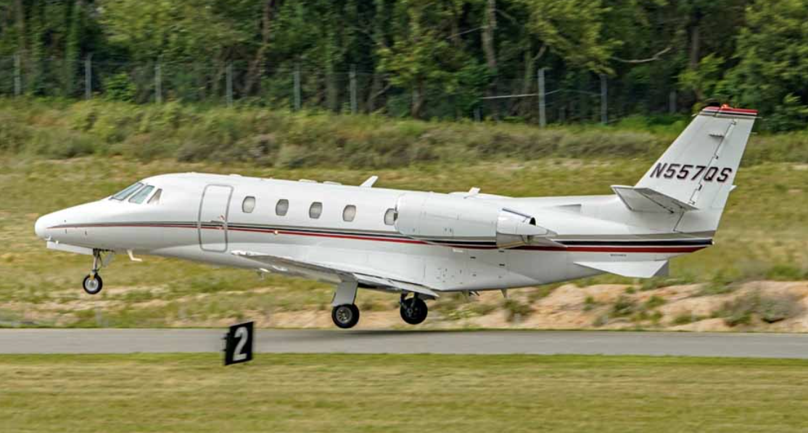
Jet | Gulfstream 350 | 510 | 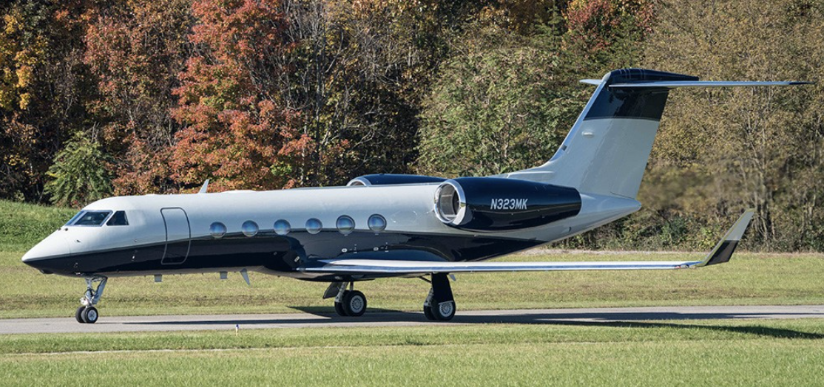

Task 3
For the existing runway length conditions and using the historical design temperature answer the following:
- Find the aircraft that are limited in takeoff weight operating from FCI on a wet runway.
- For dry runway conditions, find the takeoff weight and useful load possible for the Hawker 800XP and the Beechcraft King Air B350 operating from the existing runway.
- Using the existing runway length at FCI, find the maximum distance that can be flown by a Hawker 800XP with seven passengers and two pilots departing on a wet runway.
- Can the Cessna 560XL operate at FCI under Part 135 rules if the runway is wet?
Task 4
Considering climate change conditions answer the following:
- Using the existing runway length at FCI, find the maximum distance that can be flown by a Hawker 800XP with seven passengers and two pilots departing on a wet runway. Comment on change in maximum distance compared to part (c).
- For dry runway conditions, find the takeoff weight and useful load possible for the Hawker 800XP and the Beechcraft King Air B350 operating from the existing runway. Comment on the useful load changes compared to Part (c).
- Overall, how does increased temperature in the future (with climate change) may affect aircraft operations in the future?

Problem 3
The airport described in Problem 2 is planning a possible runway expansion to accommodate larger jet aircraft such as the Gulfstream G200 and the Bombardier Global Express 6000. Table 3 shows information for two aircraft identified in the new airport master plan.

Table 3. Additional Fleet Mix for Problem 2.
Aircraft Type | Aircraft | Annual Operations | Picture
Jet | Gulfstream G200 | 410 | 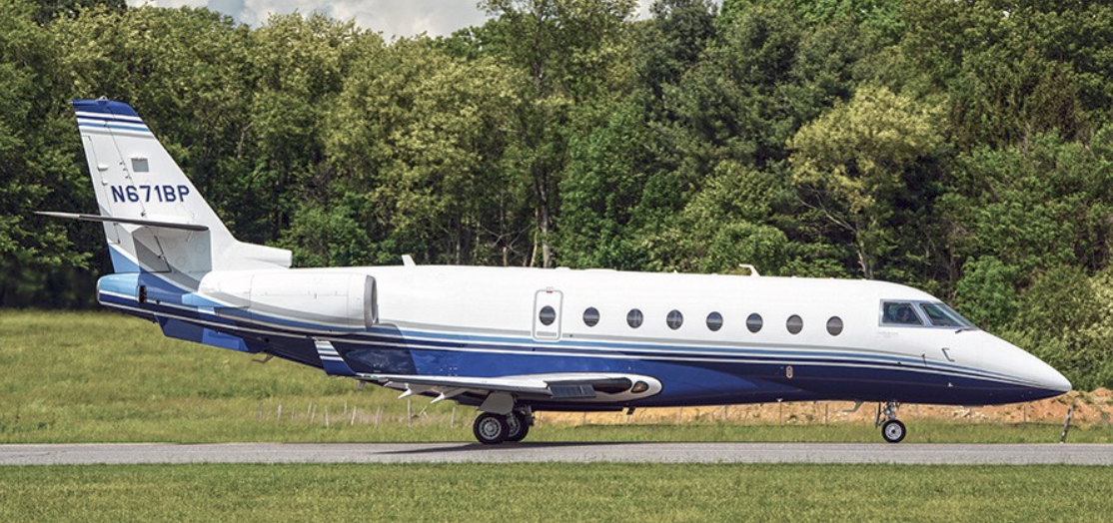
Jet | Bombardier Global Express 6000 | 345 | 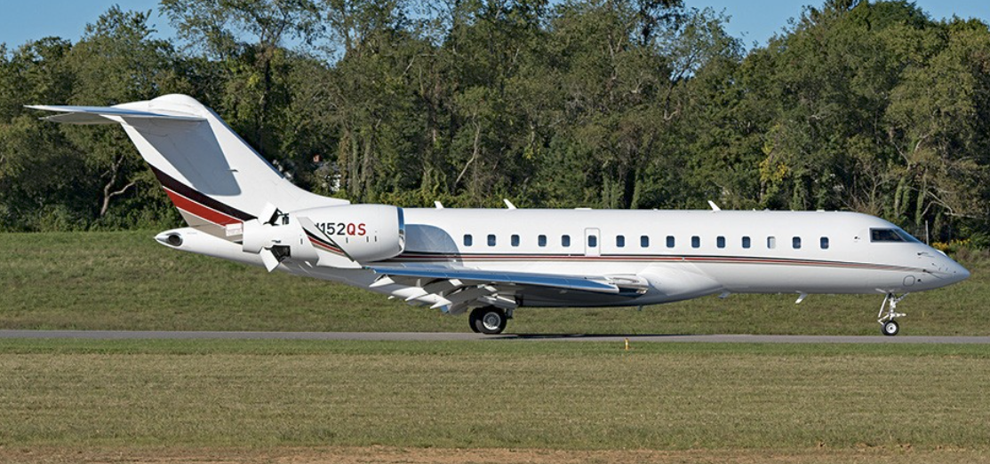

Provide answers to the airport client for a proposed runway extension.
- Find the runway extension needed at FCI to allow both all turbofan-powered aircraft to operate at a useful load of 60% in wet pavement conditions. In the analysis consider future climate change temperature conditions (2035-2065). Tell me the total runway needed to satisfy the 60% useful load requirement for both aircraft.
- With the proposed runway extension, how far can the Global 6000 fly with eight passengers and two pilots?
- With your proposed runway extension, can the Global 6000 fly from FCI to London Heathrow Airport non-stop considering climate change effects and the future design temperature? In the analysis consider a typical 6% detour factor applied to the Great Circle Distance for trans-Atlantic flights.

Problem 4
Please answer true or false.
Question | True / False
Jet engines produce more thrust as airspeed increases.
Piston-engine aircraft performance is very sensitive to airport elevation.
The air density in Denver, Colorado is 25% lower than at sea level.
Runway slope increases the runway length needed.
Landing speeds remain the same at higher elevation airports for a constant flap setting.
A 30-deg. flap setting produces more drag than a 10-deg. flap setting.
Climb speed increase with higher takeoff weight.
Large flap angles are desirable during landing.
Long runways are needed at airports like La Paz, Bolivia (13,325 feet above sea level).

