CEE 4674: Airport Planning and Design

Assignment 1: Familiarization with Aviation Data Sources and Aircraft Classifications

Date Due: September 4, 2026 Professor: A.A.Trani

Problem 1
Download the latest version of the FAA Advisory Circular 150/5300-13B with Change 1 (see the link on our home page). Read carefully Sections 1.1 to 1.2.3 and 1.6 of the advisory circular before answering the following questions.
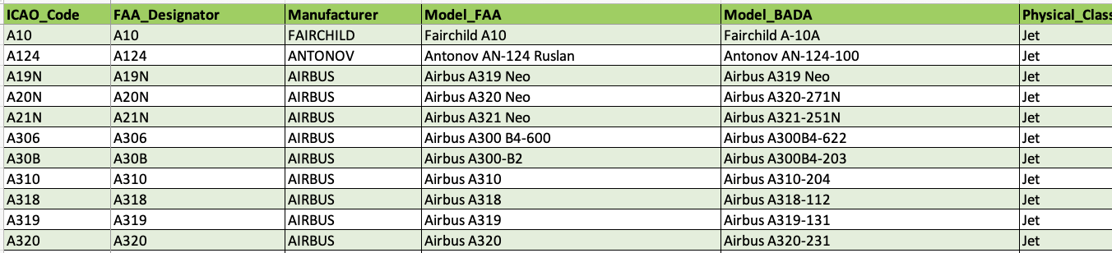
Also, download the FAA Aircraft Characteristics Database at: https://www.faa.gov/airports/engineering/aircraft_char_database (second item in the home page).
Aircraft Characteristics Database.

- Briefly state the differences between standards, recommended practice and requirements used in airport design.
- Explain the differences between FAA and ICAO aircraft design groups when designing airports.
- Why would the Taxiway Design Group be important in airport design?
- Use all the aircraft in the Aircraft Characteristics Database and make a plot of the aircraft length (x-axis) versus the aircraft maximum takeoff weight (labeled as MTOW). Label the axes accordingly and comment if there is any correlation between the two parameters. Comment on the observed trend.
- Why is wake turbulence classification important in airport design? Comment.

Problem 2
Answer the following questions using the FAA Aircraft Characteristics Database at: https://www.faa.gov/airports/engineering/aircraft_char_database.
- A new general aviation airport is planned to have a 6000-foot long runway. The Global Express 6000 - FAA Designator GLEX (see Figure 1) is expected to be the critical aircraft. Find the ADG, AAC, RDC, and TDG code for the airport. The airport is expected to have an Instrument Landing System with a visibility lower than one statute mile but not lower than 3/4 statute miles.
- An airport in Asia is designed to accommodate the Boeing 787-9 (see Figure 2). Find the ICAO Aerodrome Reference Code (Element 2) to define the size of the terminal gates.
- Find the airport ADG, AAC and TDG codes allowing an airline to conduct operations with Boeing 777-200 aircraft (see Figure 3). Assume the visibility minima is 1/2 statute mile. State the ICAO Aerodrome Reference Code (Element 2) for the Boeing 777-200.
- A new airport project identifies the Boeing 737-8 Max (see Figure 4) as the critical aircraft for the future facility. Find the ADG, AAC and taxiway design groups to design the airport.
- NASA Langley has been working on supersonic low-boom aircraft designs (see Figure 5). For the 60-passenger supersonic configuration shown in Figure 5, find the ADG, AAC and TDG groups to design the airport. The estimated landing speed of the low-boom design is 160 knots. Comment on the physical features of the aircraft to be accommodated at existing airport gates.
- A Colorado-based company called Boom has been working on a supersonic aircraft design called Overture (see Figure 6). The wingspan of the Overture is quoted at 106 feet. The main gear width of the Overture is estimated to be 28 feet. Find the ADG, AAC and TDG groups to design the airport. The estimated landing speed of the Overture is 163 knots.
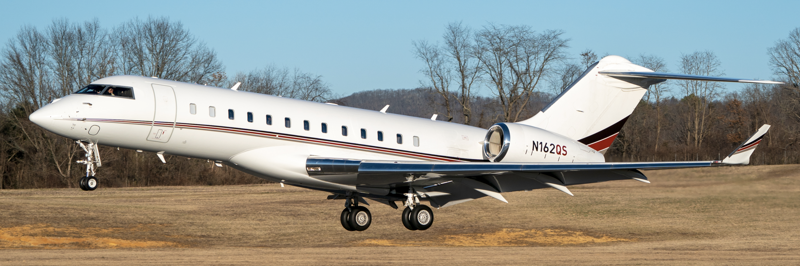
Figure 1. Global Express 6000. Source: A. Trani.

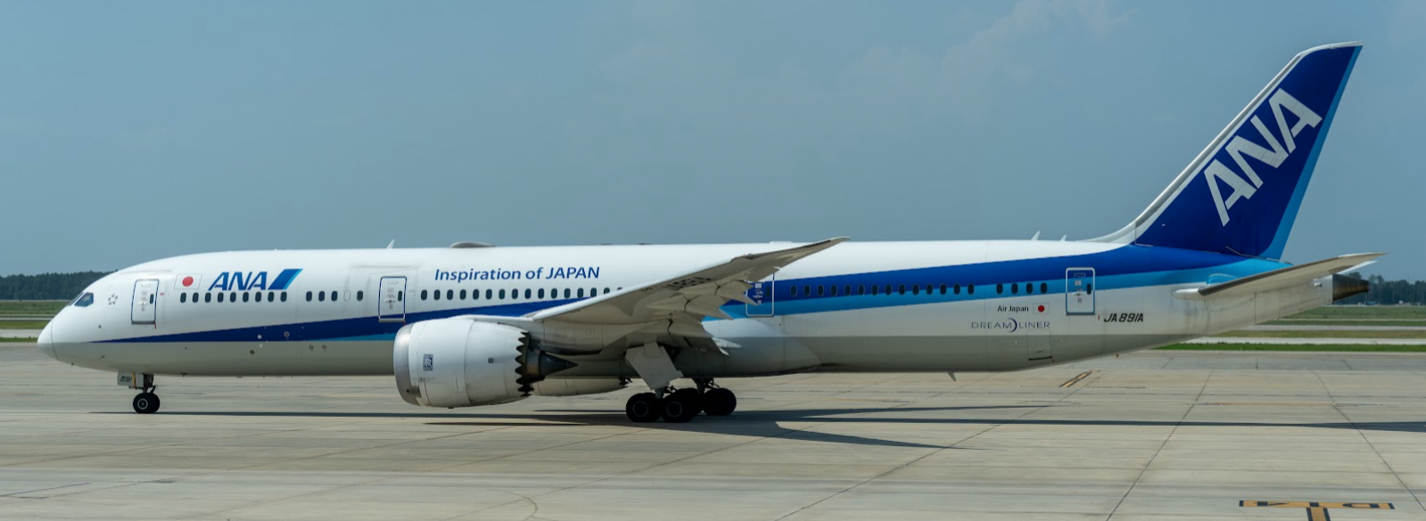
Figure 2. Boeing 787-9 Taxiing at Houston Intercontinental Airport (IAH). Source: A. Trani.

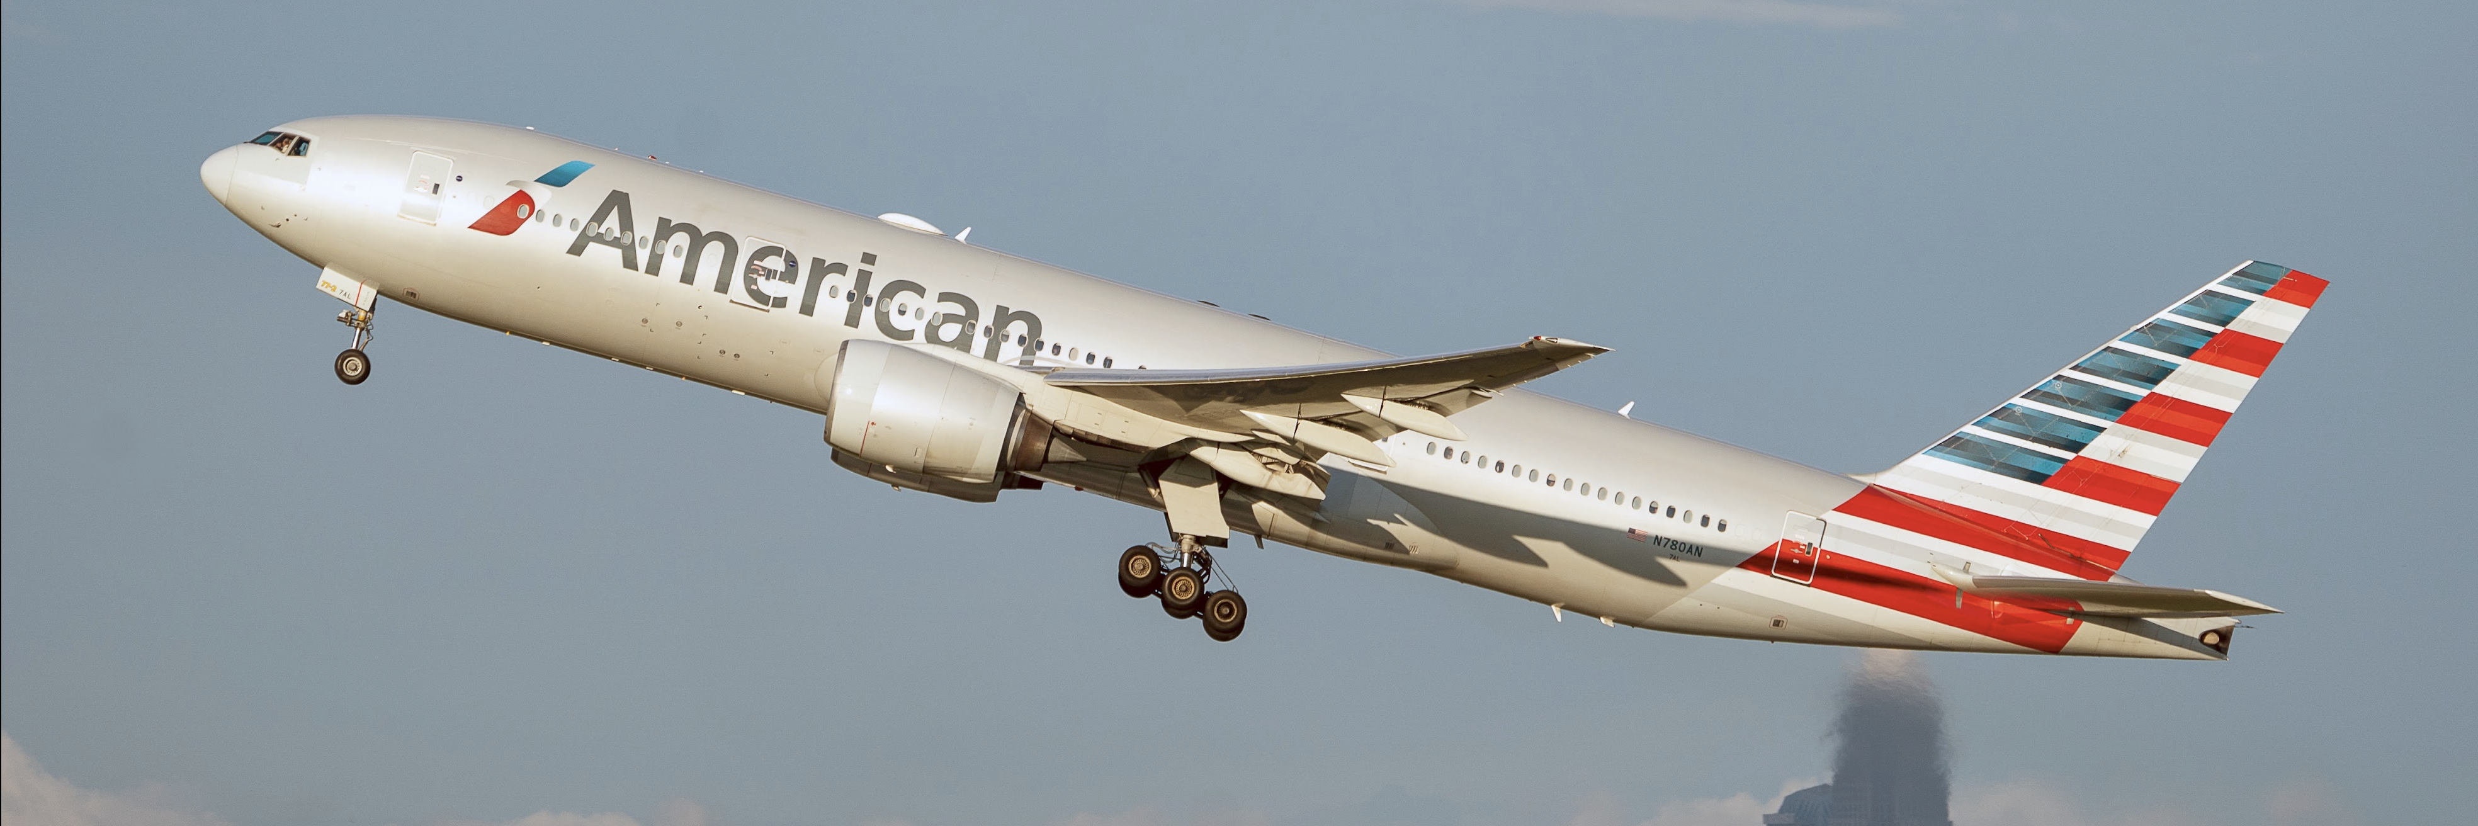
Figure 3. Boeing 777-200 Departs Charlotte International Airport (CLT). Source: A. Trani.

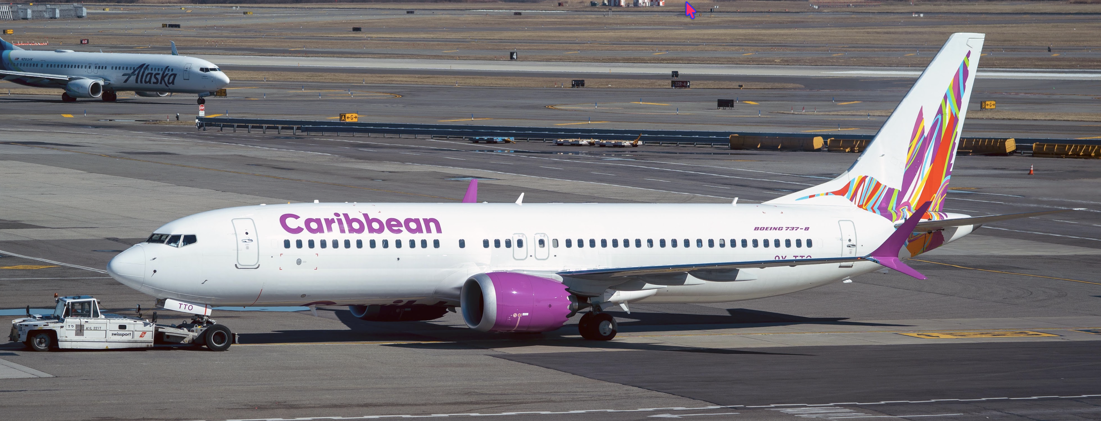
Figure 4. Boeing 737-8 Max in Tow at John F. Kennedy Airport (JFK). Source: A. Trani.

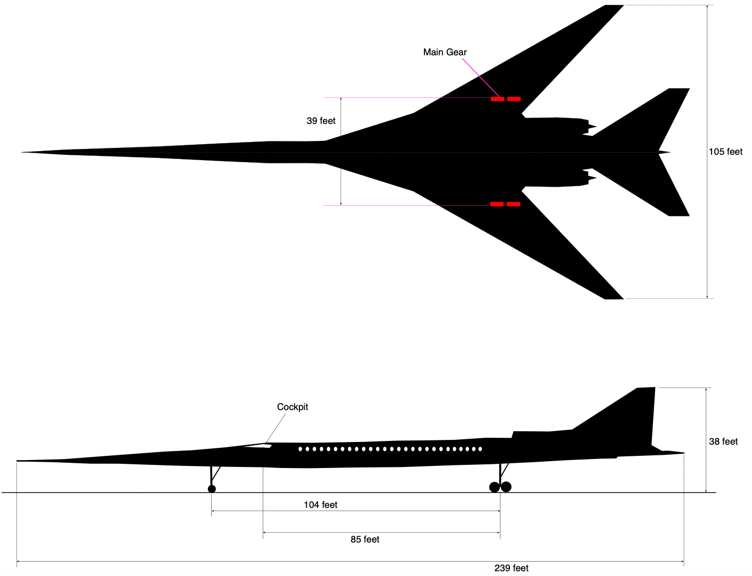
Figure 5. Conceptual 60-passenger Low Boom Supersonic Aircraft. Source: NASA Langley.

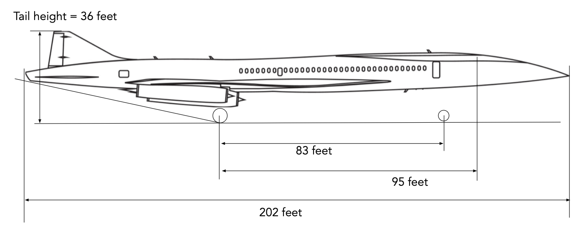
Figure 6. Boom Overture Supersonic Aircraft. Source: Boom.

Problem 3
Identify the commercial aircraft presented in Table 1. Find the FAA Aircraft Design Group (ADG), Taxiway Design Group (TDG), Aircraft Approach Class (AAC), and Consolidated Wake Turbulence (CWT) categories. Here is a list of possible choices (more choices than pictures to add a little challenge): Embraer Phenom 300 (E55P), Cessna Citation Latitude (C68A), Boeing 787-8 (B788), Boeing 737-800 (B738), Boeing 717-200 (B712), Beechcraft King Air 350 (B350), Cessna 172 (C172), Airbus A320-200 (A320), Pilatus PC-12 (PC12), Cirrus SR-22 (SR22), and Airbus A321neo (A21N). Use the FAA Aircraft Characteristics Database to get information about ADG, TDG, AAC.
To help you identify the aircraft use my web site which contains similar pictures with annotations (https://photos.app.goo.gl/8bdSvdwPQU7lHIDi2). Other good sites to help identify aircraft are Airliners.net http://www.airliners.net and Jet Photos http://www.jetphotos.net.

Table 1. Aircraft for Problem 3.
Picture | Aircraft Name | ADG | TDG | AAC | CWT
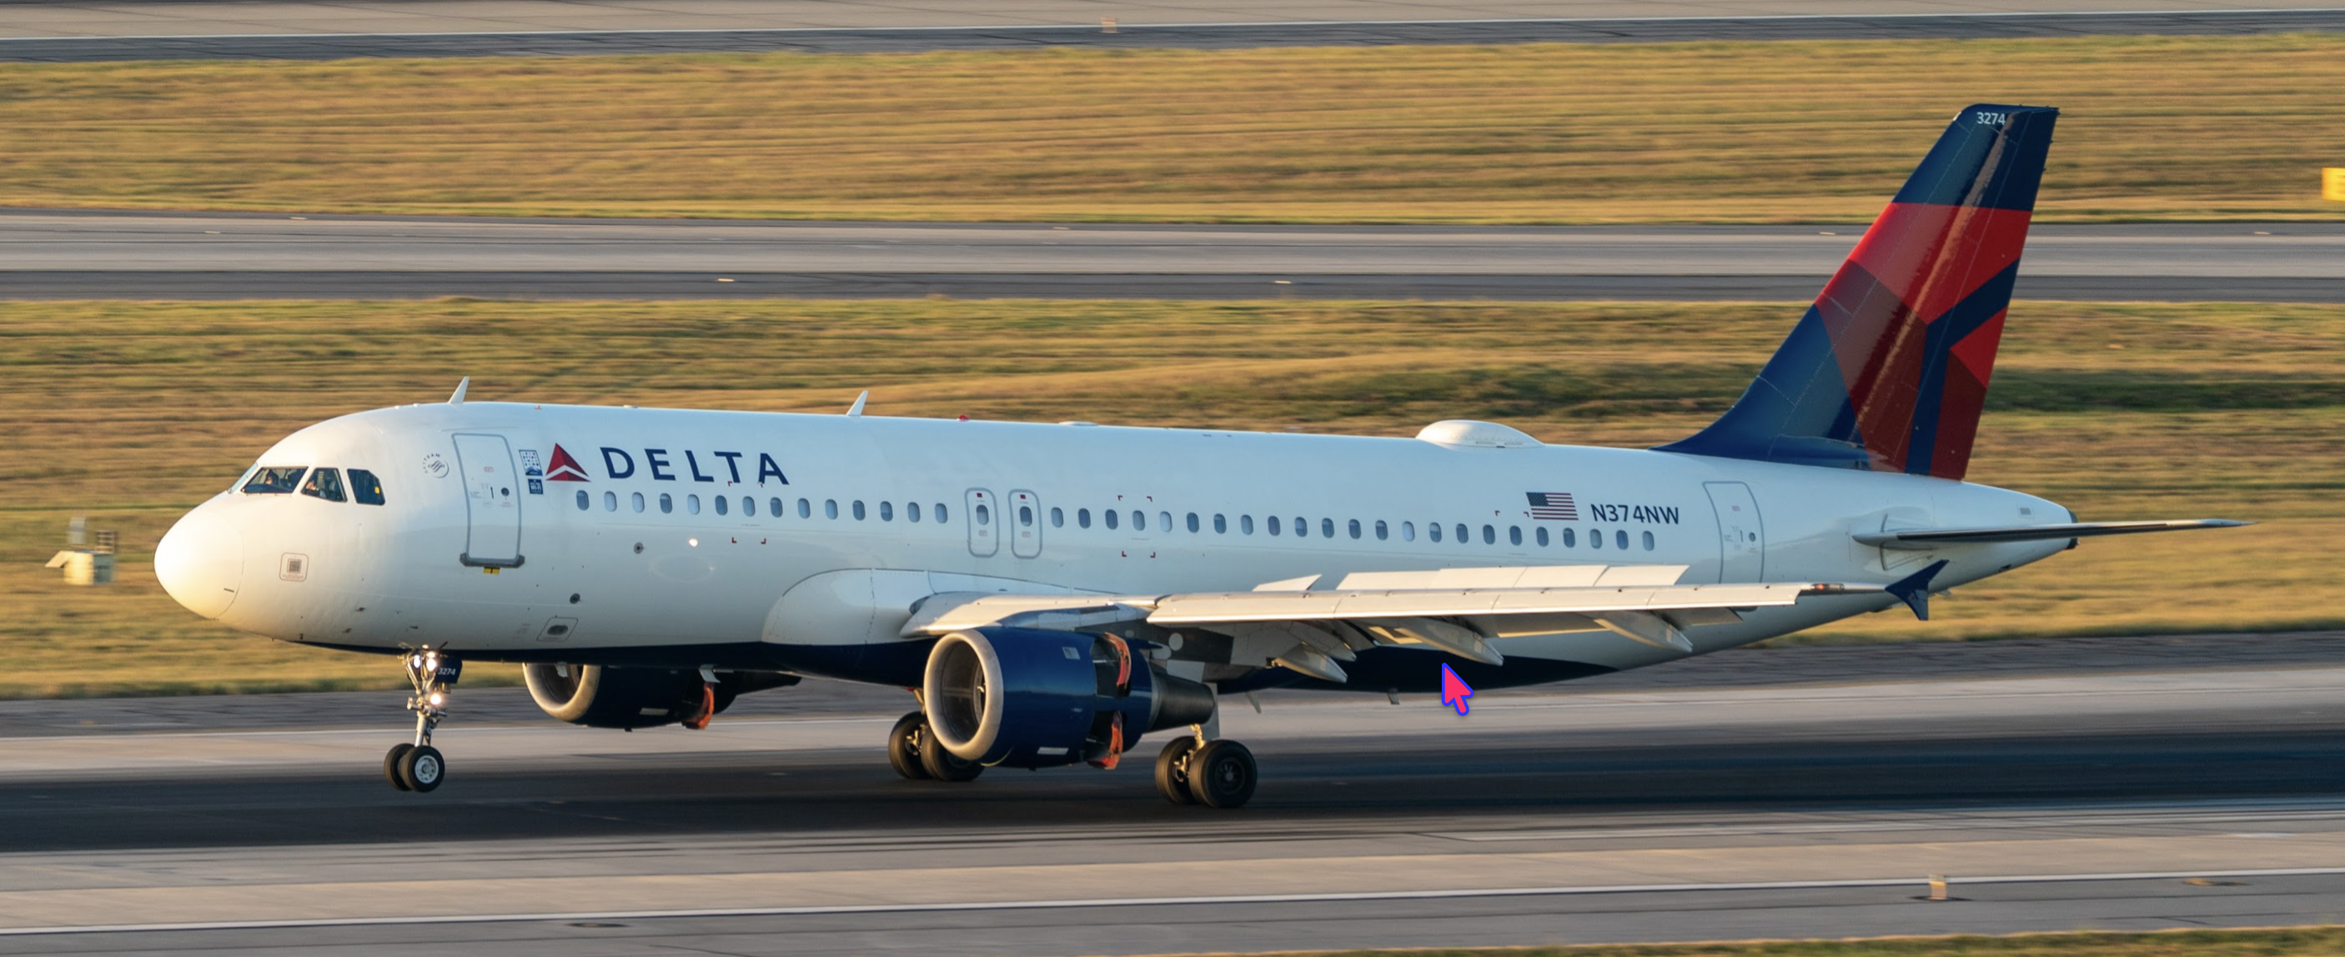 | Airbus A320-200 | III | 3 | C | F
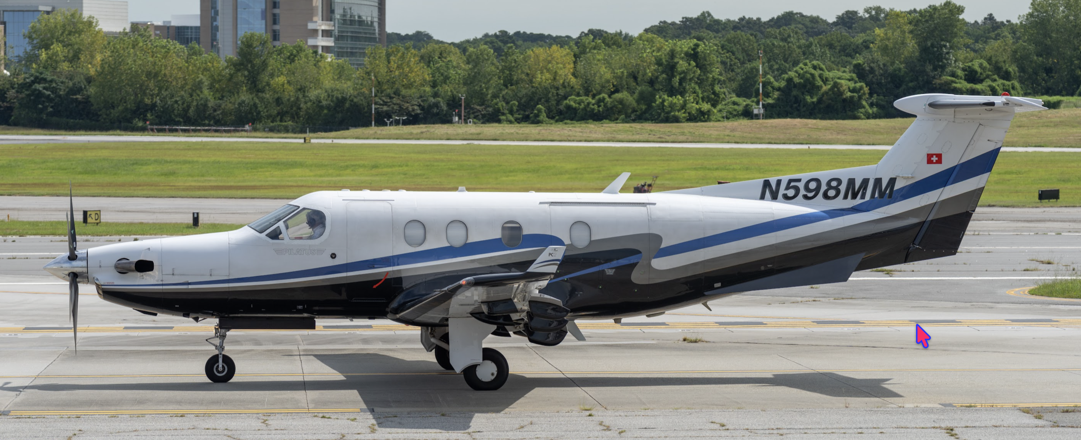
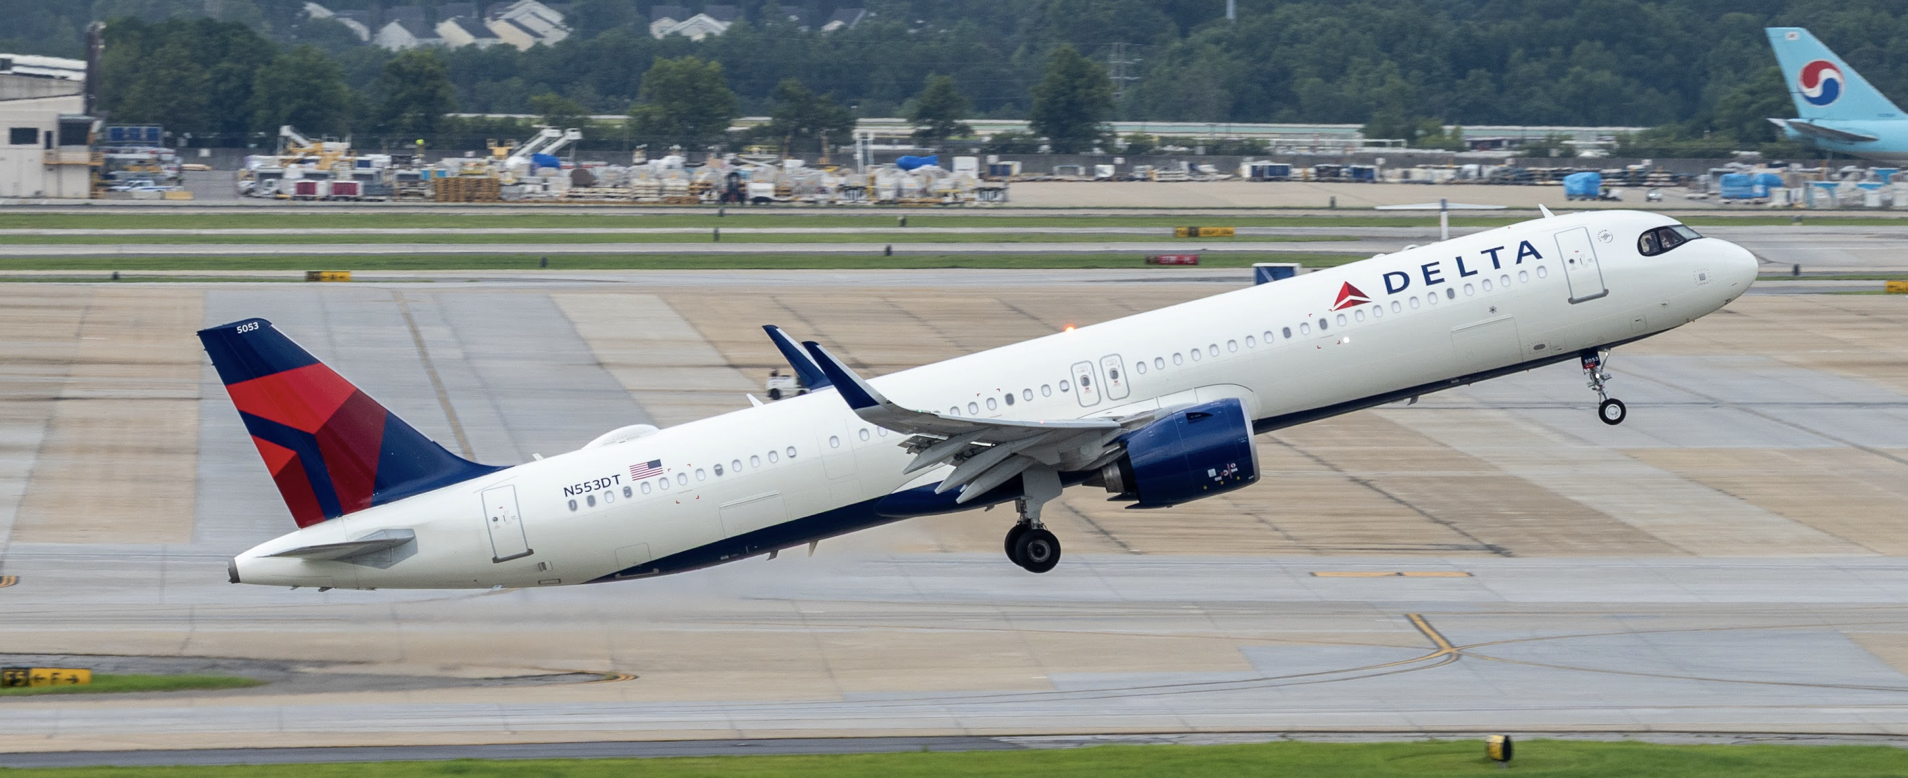
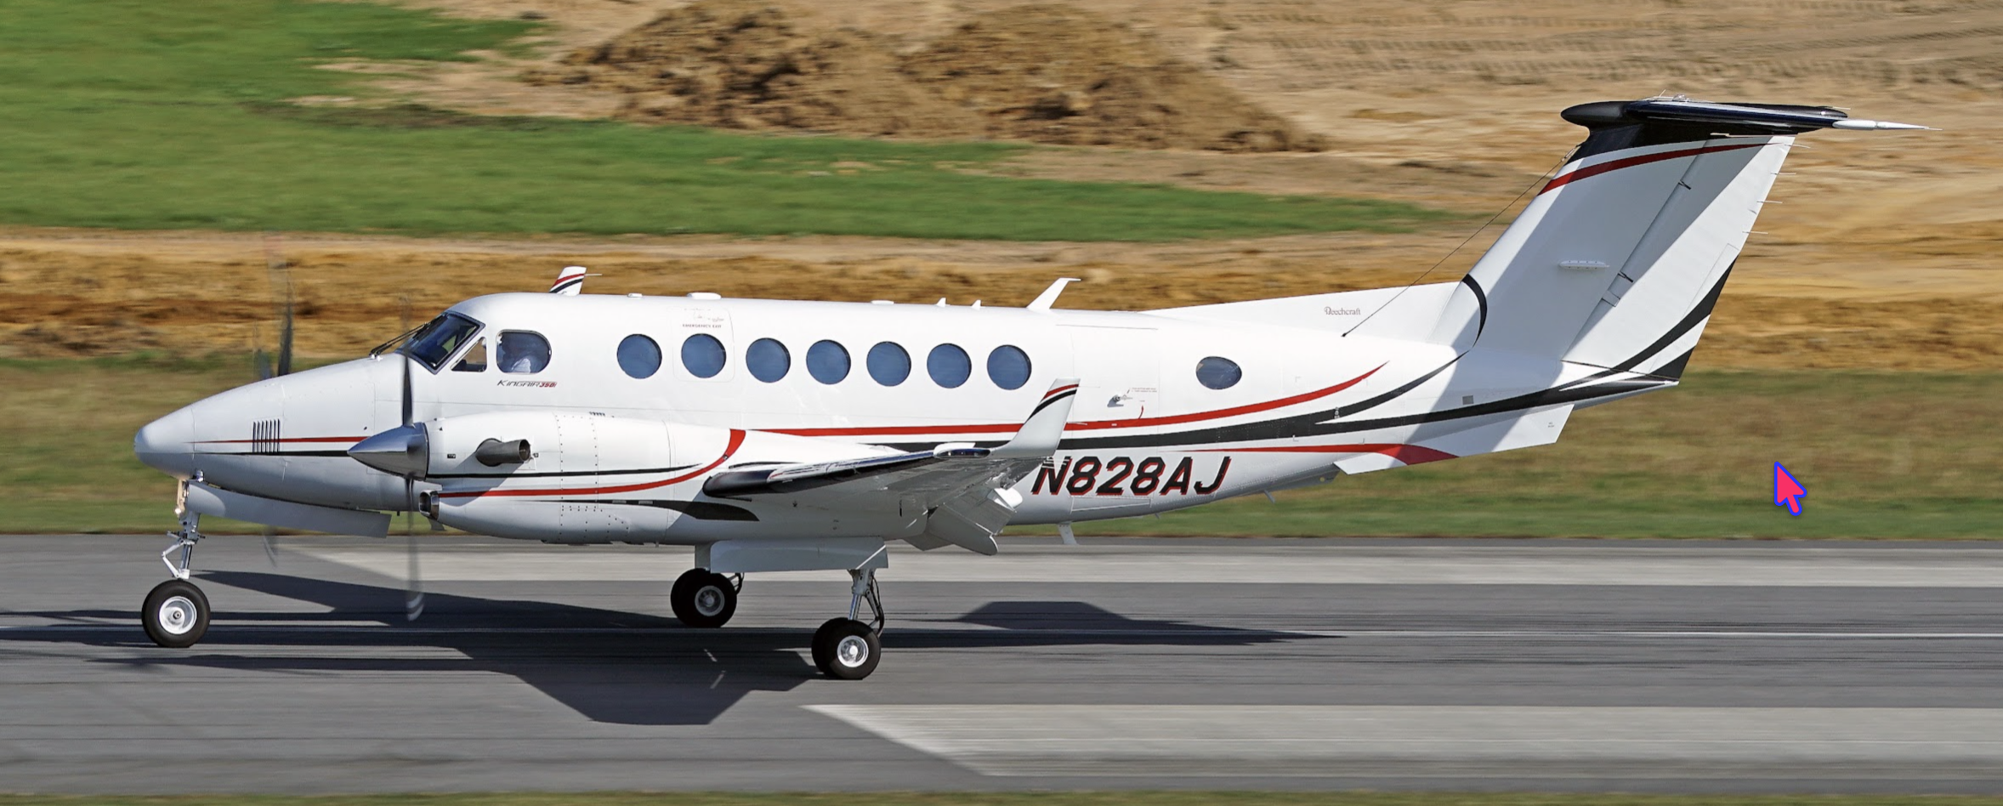
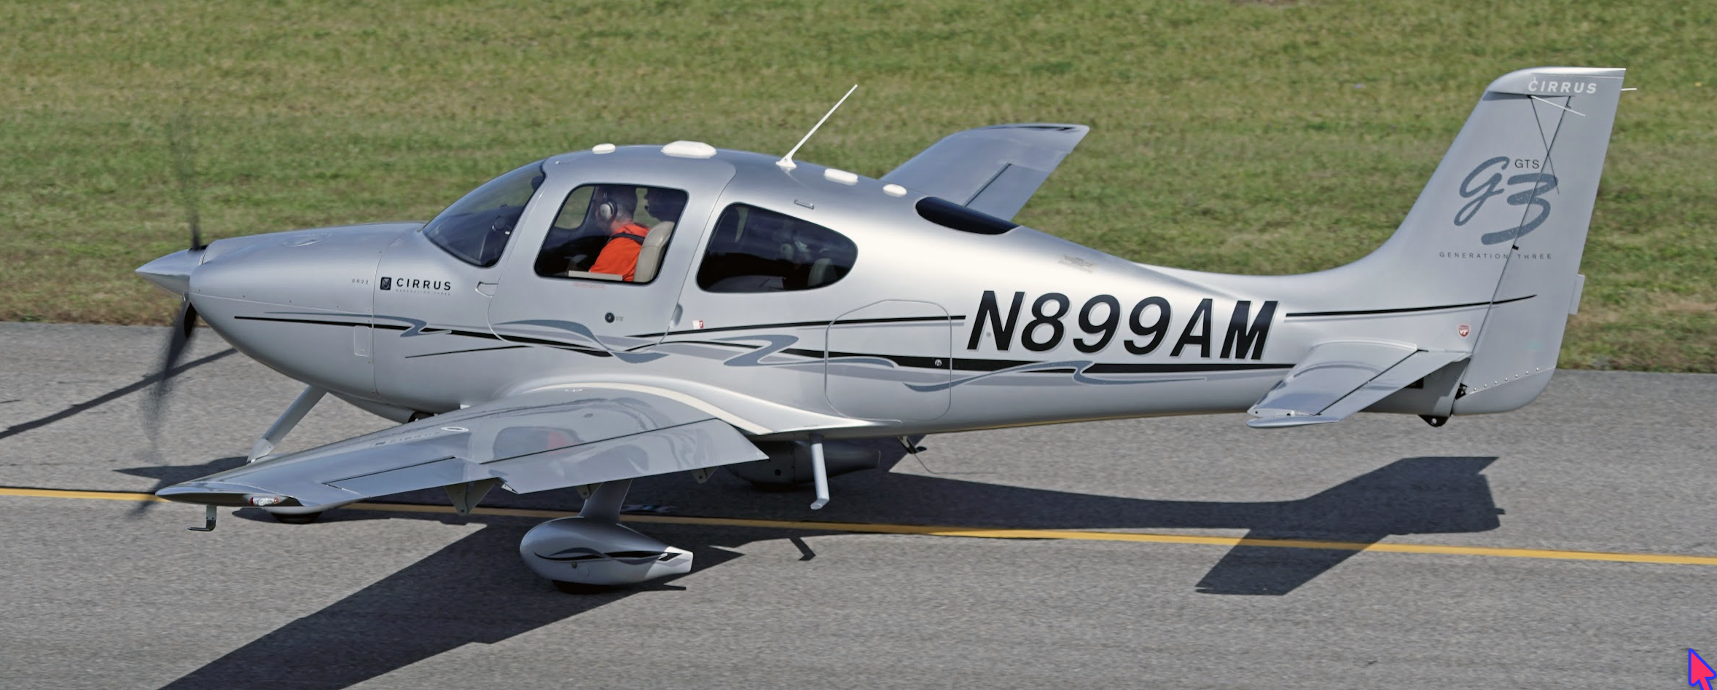
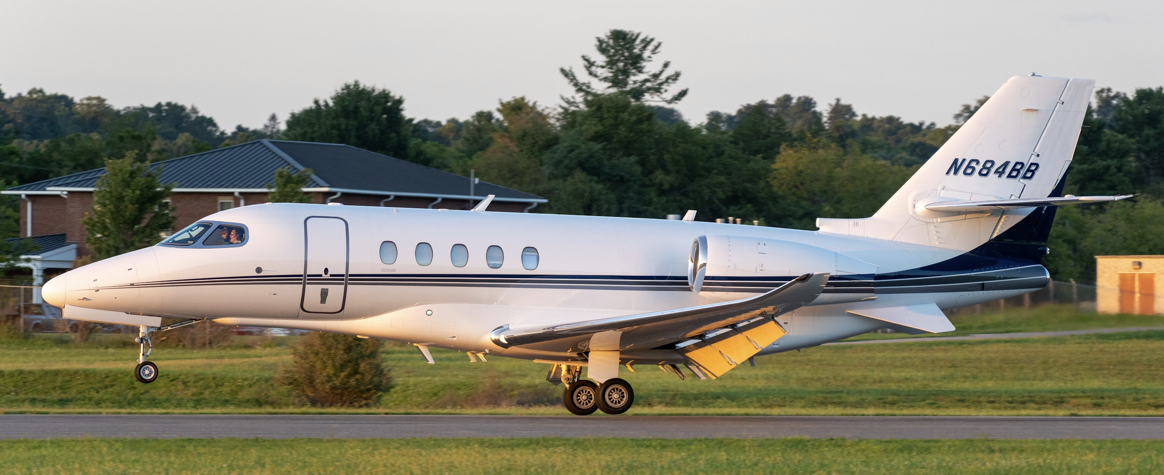
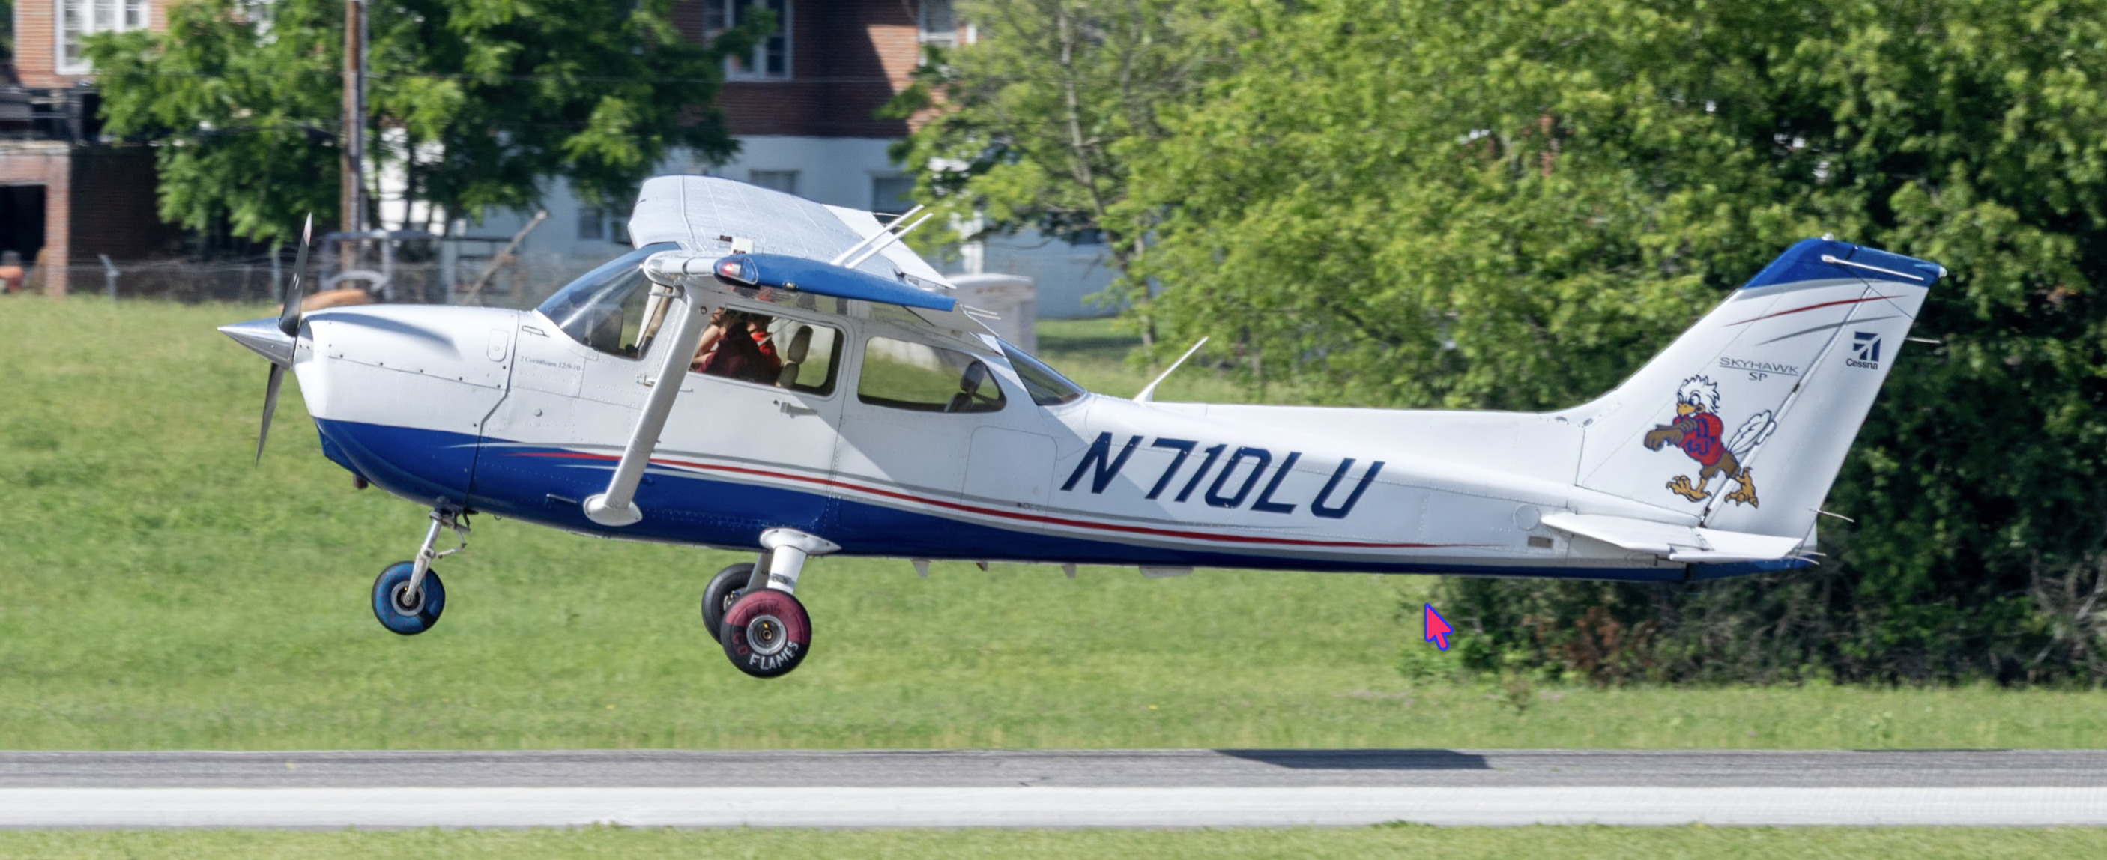
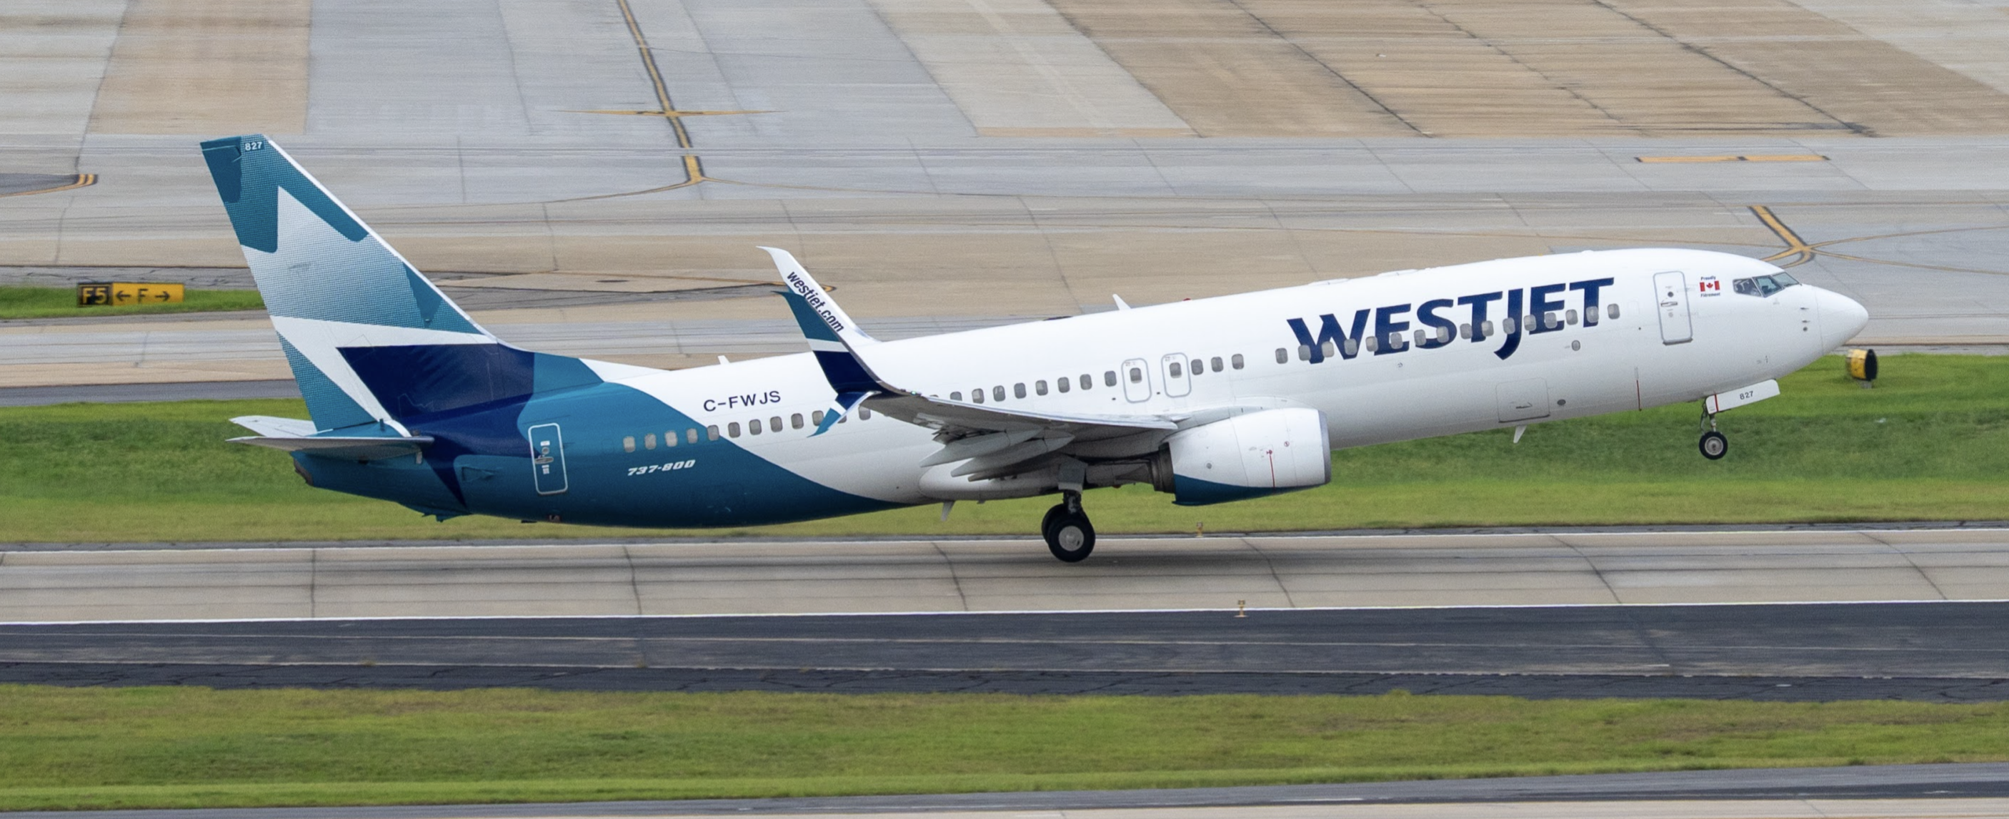
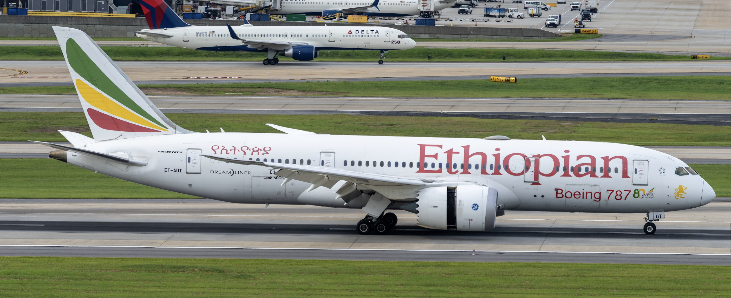

Problem 4
True or false (T/F) or short answer (SA) section.
Question | True / False or Short Answer
Number of airports in the National Plan of Integrated Airport Systems (SA).
In the mid-1920s, Ford built a successful commercial aircraft. Name the aircraft (SA).
Los Angeles International Airport (LAX) was reconfigured in the late 1950s to accommodate jet aircraft (T/F).
Turboprop aircraft operated in the late 1950s required 7,900 feet of runway when operated at sea level conditions (T/F)
The US fleet of regional jet aircraft increased more than ten-fold between 2000 and 2022 (T/F).
The introduction of the Boeing 747-100 in 1969 doubled the passenger capacity of the previous generation of jet aircraft (e.g., Boeing 707-300) (T/F).
Name of the aircraft introduced in 1936 that changed commercial aviation with more than 11,000 aircraft produced (SA).
The average runway length of the NPIAS airports in the US is 5,600 feet (T/F).
Most of the commercial air travel between continents in the late 1930s was done using flying boats (T/F).
The Douglas DC-8-50 required a runway length of 6,500 feet (T/F).

