CEE 3804: Computer Applications for CEE Spring 2012

Quiz 3
Date:April 24, 2012 Instructor: Trani

Honor Code Pledge

The information provided in this exam is my own work. I have not received information from another person while doing this exam.

Your Name ________________________________________________

Your Signature _____________________________________________

Write your solutions in a single MSWord file. Create a PDF file. Cut and Paste all your answers using screen captures. Show all your work. Label your file with your last name and CEE3804. Email your solutions to vuela@vt.edu and tao81@vt.edu. In the email header use the words CEE 3804 Quiz.

Problem 1 (50 Points)
You are given the task to calculate the volume of earth material to be removed from a hill during the construction of an Interstate Highway . Figures 1 and 2 illustrate the situation. The blue dots in Figure 1 constitute the surveyed elevation points on the hill contour where the cut is to be made. The red line in Figure 2 represent a polynomial approximation of the hill elevations. The elevations and stations of the surveyed points are shown below.
station = [1.75 10 20 30 40 50 60 70 80 90 100]; % in meters
elevation = [5 26 43 51 53 49 40 29 18 8 0]; % in meters
- Create a Matlab script to estimate the area under the hill contour shown in Figure 1. The highway vertical alignment has a slope of 5.09% between stations 0 and 100 (metric) as shown in Figure 1. In the analysis, use the polynomial of your choice to approximate the elevation contour of the hill shown in Figure 1.
- Improve the script in part (a) to calculate the volume of earth material (in cubic meters) to be removed for the road construction project. In your volume calculations, assume the average width of the cut is 35 meters at the section of the highway alignment as shown in Figure 2.

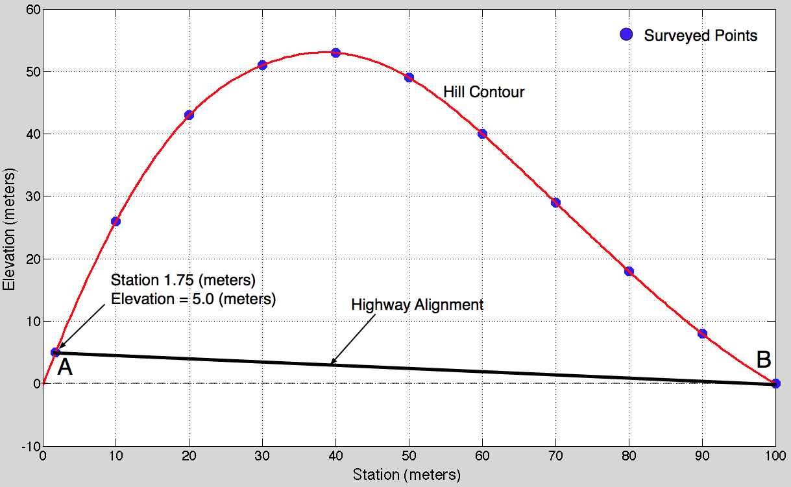
Figure 1. Cross Section of Hill Contour to be Removed for the Road Construction.

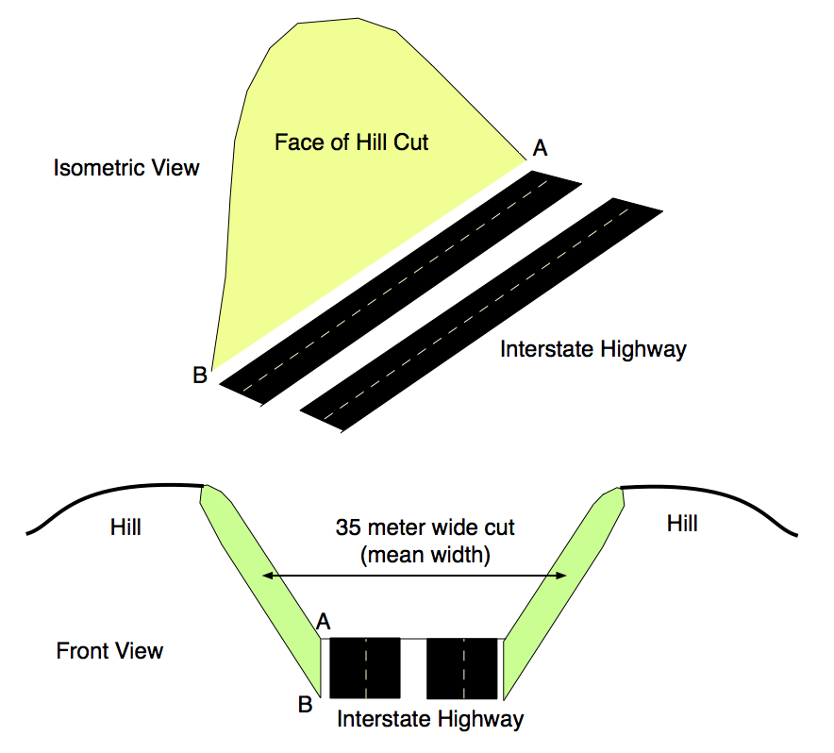
Figure 2. Isometric and Front Views of Hill Cut Required for Road Construction.

Problem 2 (50 Points)
One important problem to civil and environmental engineers is the treatment of water to avoid bacteria growth. A differential equation developed by Monod and modified by Smith to estimate the growth of bacteria in a water medium is given by:
(1)
where:
= is the rate of change of bacteria concentration in the water medium per unit of time (grams/liter per hour)
= bacteria concentration in water (grams/liter)
= bacteria growth rate factor (1/hour)
= model constant (dimensionless)
= half-saturation constant (grams/liter)
= concentration of bacteria nutrient (grams/liter)
= initial bacteria concentration in the water (grams/liter)
Note that all units in equation (1) are consistent (no need to change units). Also note thatis the initial condition for bacteria concentration in water and also a constant.

- Your task is to develop a Simulink model to estimate the growth of bacteria for the first 6 hours after the water is contaminated with some initial bacteria concentration (). Use the following initial conditions for the problem:
grams/liter - concentration of bacteria nutrient
grams/liter - initial bacteria concentration
In your model use the following constants:
dimensionless
grams/liter
per hour
- Export the results of the Simulink model (i.e., time and bacteria concentration ) to Matlab and make a plot showing the growth of bacteria concentration () over 6 hours. Estimate (using the plot) the bacteria concentration after 5 hours. Label the plot appropriately.

