CEE 3804 Exam1 (Spring 2024)

Computer Applications in Civil Engineering

In-Class Exam: Open Book and Notes

Your Name __________________________________________________________________

Your Signature * ____________________________________________________________
- The answers in this exam are the product of my own work. I certify that I have not received, nor I have provided help to others while taking this examination.
Directions:
Solve the problems. Copy and paste the VBA code and solutions such as graphs in a Word Document and convert to a single PDF file. Make sure your code is not too small for me to be able to read it. Minimum font size 12 is acceptable.

Problem 1 (30 points)
Figure 1 shows a file containing marine dock facilities in the United States and US Territories. The file is provided in the assignments website.
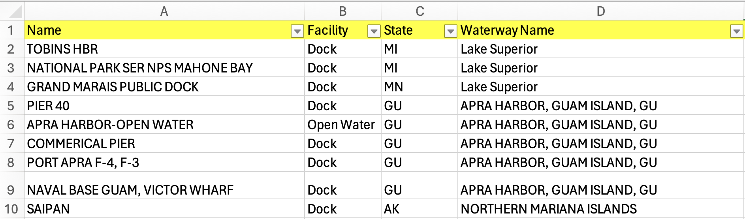
Figure 1. Docks in the United States and US Territories.

The fields in the file are explained below.
Name - name of the facility.
Facility - type of facility (docks, anchorages, junctions, etc.)
State - the State or US territory.
Waterway name - name of the waterway where the facility is located.
Port name - name of the port where the facility is located.
- Create a Pivot Table (a matrix) to count the number of facilities (in columns) for each state (in rows).
- Tell me the number of docks in the state of Florida (FL) and in Guam (GU).
- Create a Pivot Chart to count the number each type of facility. Make sure the Pivot Chart has labels.

Show me the upper left portion of the Pivot Table and the full Pivot Chart. Highlight the numbers with your answers.

Problem 2 (30 points)
Engineers test a new commuter train and measure the noise level generated at different speeds. One of the civil engineers in the team, proposes a quadratic regression equation to approximate the noise level produced as a function of speed.
$$L_{eq}=A+BV+CV^{2}$$
where:
$L_{eq}$ is the equivalent noise level produced by the train (in decibels - dBA)
$V$ is the train speed (in miles per hour)
$A,B,C$ are the regression constants of the model.
After numerous tests, the numerical values of the constants $A,B,C$ are:
A = 40.486
B = 1.2984
C = -0.0086
All constants are dimensionally correct to produce a value of $L_{eq}$ in decibels (a unit of noise level).

- Write a Public Function in VBA to estimate the equivalent noise level ($L_{eq}$) as a function of train speed ($V$). Use the equation provided in your function. Use Option Explicit in your code.
- Test the function created in part (a) to estimate the value of $L_{eq}$ for speed values ranging from 10 to 60 miles per hour at intervals of 10 mph. Show the value of $L_{eq}$ for each speed tested. To test the function, use Excel and create a two-column table with values of speed (in column A) and the calculated values of $L_{eq}$ in column B. You do not have to create the table in VBA code.

Show me all your code in screen captures. Unreadable font size will not be accepted. Please make sure the equivalent font size of the screen capture is at least 12.

Problem 3 (40 points)
A common problem in Civil Engineering is to estimate the deflection of a cantilever beam at different stations (see Figure 3).
$y=\frac{Px^{2}}{6EI}(3l-x)$ (Equation 1)
Where:
$y$ is the deflection at any point in the beam (inches)
$x$ is the distance from the wall to any point on the beam (inches)
$P$ is the load applied (lbs.)
$l$ is the length of the beam (inches)
$E$ is the modulus of elasticity (lb/in²)
$I$ is the moment of inertia (in⁴)
The units in this model are all consistent.
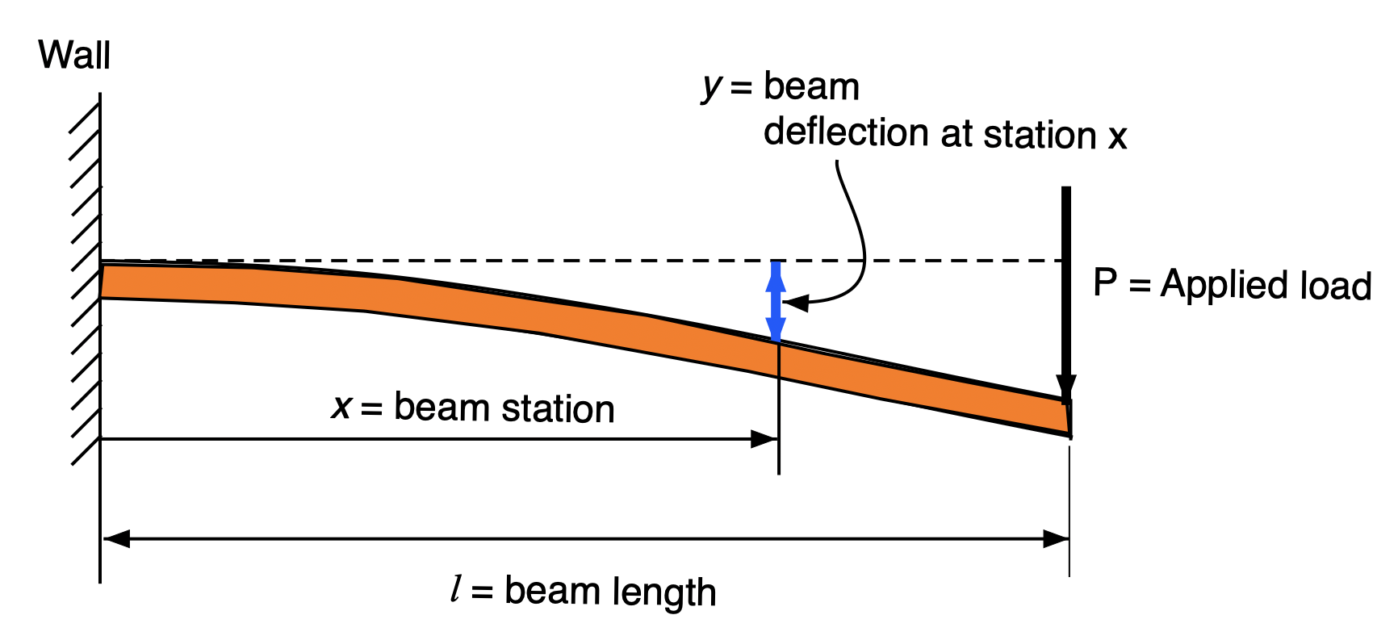
Figure 3. Cantilever Beam Subject to a Single Load (P).

Table 1 shows the values of $E$ (Modulus of Elasticity) for three materials.

Table 1. Values of Modulus of Elasticity for Two Materials.
Material | E (lb/in²)
Steel | 2.9E+07
Titanium | 1.65E+07

- Create a Visual Basic Subroutine to estimate the beam deflection ($y$) given the parameters on the right-hand side of Equation 1. The values of $x$ , $P$ , $l$ , and $I$ are defined in the Excel spreadsheet and then read by the VBA code. The VBA code reads the beam material property as a list with the names of the two materials in Table 1. The value of $E$ (modulus of elasticity) is assigned in the VBA code once the beam material has been selected from the spreadsheet. The value of deflection ($y$) is shown in the spreadsheet. Use Option Explicit in your code.
- Test the function created in part (a) with the following values:
$x$ = 174 inches
$P$ = 2000 lbs.
$l$ =250 inches
Material = Steel
$I$ = 200 in⁴

Show me all your code in screen captures. Unreadable font size will not be accepted. Please make sure the equivalent font size of the screen capture is at least 12.

